How to Pre-Identify Students
For the WY-ALT Spring 2018 administration, all students who are participating must be pre-identified in the Test Information Database Engine (TIDE). To pre-identify a student, simply add them to TIDE.
Since TIDE was pre-loaded with student information for each school, your student may already be pre-identified. Please check by going to the “View/Edit/Export Student” page under the “Student Information” task in TIDE and searching by student’s name or WISER ID. If your student appears, please ensure the pre-loaded information is up to date and that Alternate Assessment Tester is switched to yes. If your student is not in TIDE, you will need to manually add your student.
To add your student(s) to TIDE, you may select either test administration: WY-ALT Spring 2018 or WY-TOPP 2017-2018. While the WY-ALT Spring 2018 Test Administration includes several tasks specific to WY-ALT, the Student Information Task is shared across both administrations.
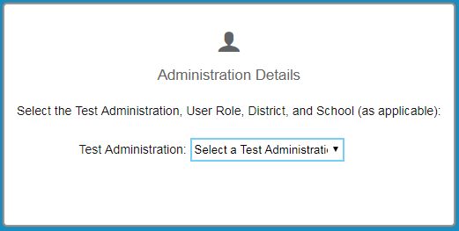
Once you are logged into TIDE, go to “Add Student” or “Upload Student Information” (if adding multiple students) under the “Student Information” task in TIDE.
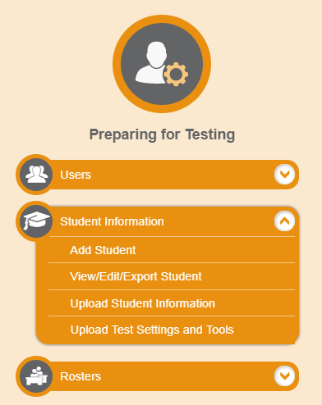

Adding Students One by One
Go to the “Add Students” page and fill in all fields in Section 1 (“Student Information”) and Section 2 (“Test Eligibility”). Make sure the student is identified as an Alternate Assessment Tester (under “Test Eligibility”). You do not need to fill anything out for Sections 3-9.
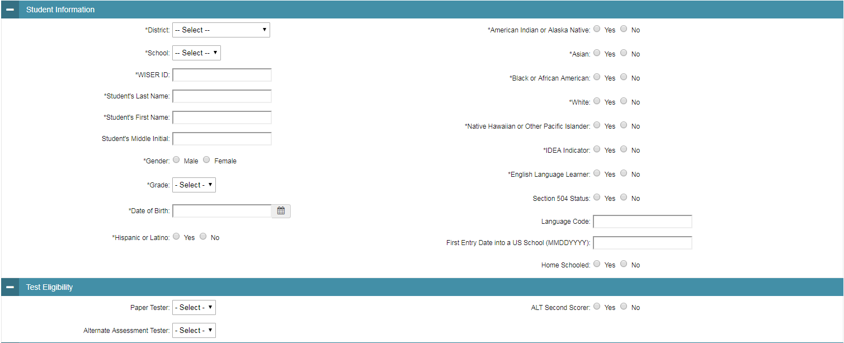
Hit “Save” at the bottom of the page. Your student will then be pre-identified in TIDE.

Adding Multiple Students At Once
Go to the “Upload Student Information” page and download a CSV or excel file.
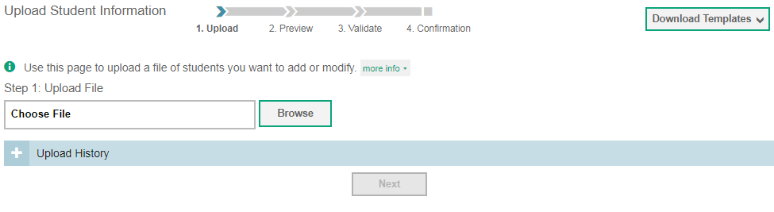
Enter in the correct information for all columns. Make sure they are identified for Alternate Assessment (column V). For instructions on how to fill out each column, see pages 40-43 of the TIDE User Guide.
Save the file. To upload the file, click Browse, select the file, and then click “Next”.
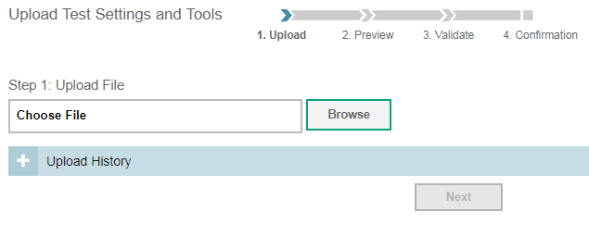
On the “Preview” page, check that the student information you entered into the uploaded file looks correct. Then click “Next”.
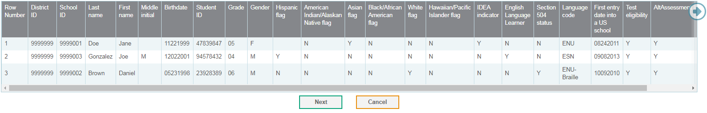
On the “Validate” page, TIDE displays any errors () or warnings (). If a column has an error, it will not be included in the upload. If a column has a warning, it will be uploaded but invalid. If you click on the error or warning icons, you can see the reason why.
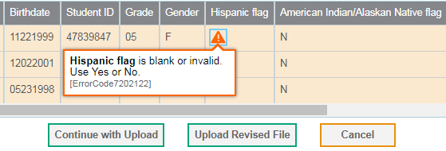
To revise a file, click “Upload Revised File”. If you are ready to upload the file, click “Continue with Upload”. Your students will then be pre-identified in TIDE.
Please be advised that TAs and Second Scorers will not be able to enter student scores into the Data Entry Interface (DEI) if the student is not pre-identified in TIDE.
The Initial Pre-ID window will close November 28, 2017. There will be an Additional Pre-ID window, opening February 12 and closing March 30, 2018.
For more information on how to add/upload students into TIDE, please see the TIDE User Guide. You can access TIDE and the TIDE User Guide from the Wyoming Assessment Portal (http://wyoassessment.org).
If you have any further questions, please contact the Wyoming Help Desk at 1-888-897-8024 or wyohelpdesk@air.org.

