Wyoming Foreign Language Standards FAQs

What are Wyoming’s standards for language learning?
The Wyoming Foreign Language Content and Performance Standards were adopted in 2013. The three Standards are the three communicative modes (Interpretive, Interpersonal, and Presentational) and emphasize that the goal of language instruction is the development of students’ communicative skills. Students learn to not only communicate in the language, but they also understand how to interact with native speakers using appropriate cultural behaviors, such as gestures and body language.

What are the three modes of communication that embody the Wyoming Foreign Language Standards?
1. Interpretive: students demonstrate understanding of spoken and written communication within appropriate cultural contexts. This includes reading, listening, and viewing.
2. Interpersonal: students engage in direct spoken, written, or signed communication with others.
3. Presentational: students present information, concepts, and ideas orally, in writing, or by signing to an audience of listeners or readers with whom there is no immediate interaction.

Since the 2013 Wyoming Foreign Language Standards are communicative modes, how is culture a part of the Wyoming Foreign Language Standards?
Cultural content statements have been added to the benchmarks to provide a culturally authentic context for all proficiency levels.

How do Wyoming’s Proficiency-based standards impact instruction?
The focus on communication emphasizes that the overall goal is for students to move beyond memorized vocabulary and grammar. Students must now learn to use a language to communicate in real-world, authentic situations.

What is the relationship between Proficiency Levels and Performance Guidelines?
- Language proficiency is defined as the ability of an individual to use language to communicate spontaneously in unrehearsed contexts. Proficiency also refers to the degree of skill with which a person can use a language to understand, speak, read, and write in real-life situations.
- Performance guidelines are the means by which educators develop proficiency in students. They describe language performance that is the result of explicit instruction in a classroom setting. Performance guidelines specify how well students demonstrate language ability at various points along the language learning continuum.

How is language learning assessed under the new standards?
- To evaluate what a student can do with the language, a student must be evaluated using performance tasks and assessments. Performance-based assessments require the learner to perform in realistic situations. Students participate in specific tasks, interviews, or performances that are appropriate to the audience and setting.
- Assessment of language learners’ proficiency, on the other hand, is based on language users providing sufficient evidence of all of the criteria of a particular level of performance according to Proficiency levels.

RESOURCES FOR ASSESSING LANGUAGE
LinguaFolio is a proficiency-based, learner-directed formative assessment tool for setting and achieving language goals.

LinguaFolio Training Modules - developed at the University of North Carolina - Chapel Hill.

NCSSFL-ACTFL Can-Do Statements - Performance indicators for language learners.

NCSSFL-ACTFL Global Can-Do Benchmarks - Self-assessment checklists used by language learners to assess what they “can do” with language in the three modes of communication.

JCPS Foreign Language Documents - Rubrics by language level and coded by language.

Why Proficiency Levels instead of grade levels?
Learners begin new language experiences at different ages and progress toward proficiency at different rates. The amount of quality time spent in the target language (i.e., immersion vs. high school level I) is a determining factor in the proficiency level that learners will reach. Learners at similar ages frequently demonstrate varying proficiency levels in all three modes of communication. The Wyoming Foreign Language Standards outline the progression of learner skills, making it easier for teachers to identify a learner’s skill level.

How much time does it take for a student to reach proficiency?
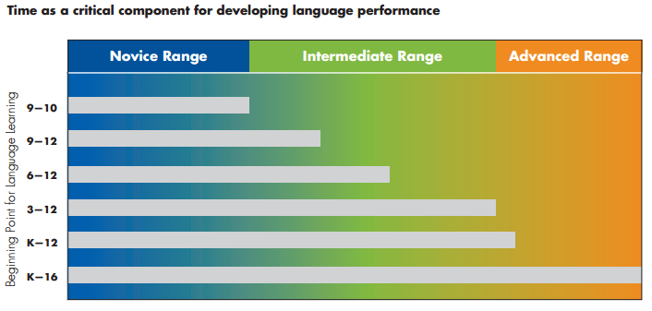
These performance targets are typical results for commonly taught languages, i.e., Spanish and French. Some languages, such as Russian, Chinese and Native American languages, require longer sequences of study to reach comparable levels of proficiency. Proficiency in the interpretive mode is the focus of classical languages, such as Latin and ancient Greek.

