Instructions for Reporting Food Safety Inspections
Fall of 2011 and Spring of 2012

1. Go to School Nutrition Programs (top left hand button).
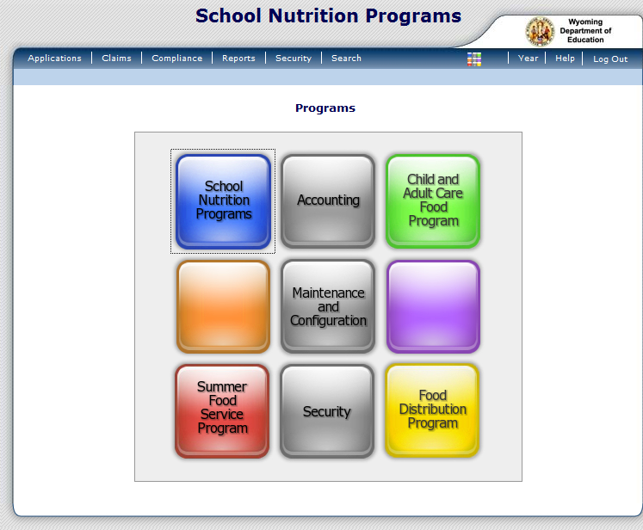

2. Then click on the Applications tab.
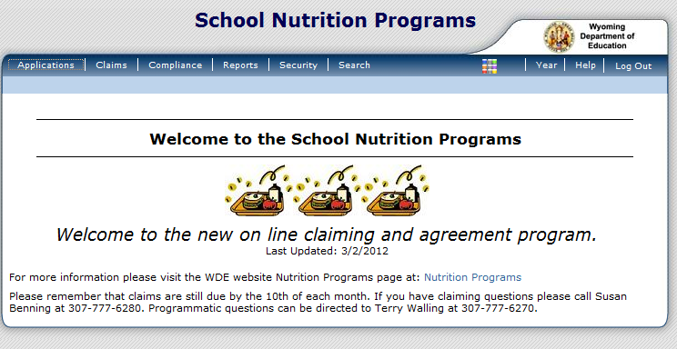

3. Click on Food Safety Inspections
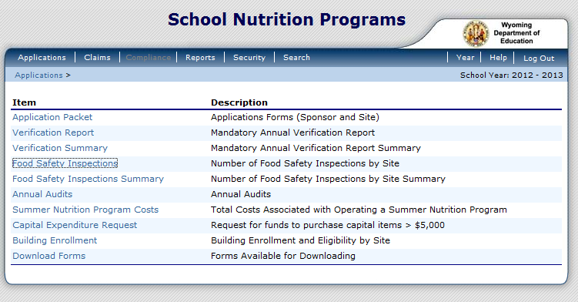

4. Click on Modify
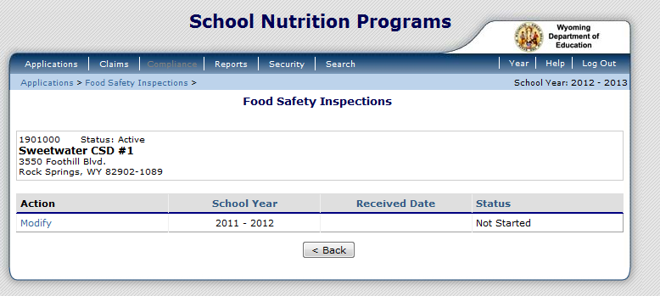

5. Complete all of the empty spaces for each school.
1. Safety Inspections performed in 2011 - 2012. For each site indicating either "Zero" or "One", select the reason in 1b.
1a. Food Safety Inspections | 1b. Reason for fewer than two inspections conducted (Select the most predominant reason).
You must complete column 1a., before column 1b. will let you use the drop down menu options. If you choose ‘Other’ in column 1b., you must give a reason. All schools must be completed. The reason box only works if you chose ‘Other’.
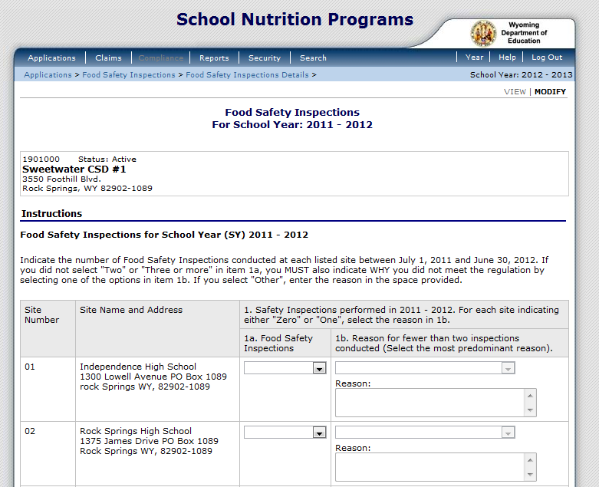

6. The Food Safety Inspection Summary box will self populate.
7. Click on the Save button.

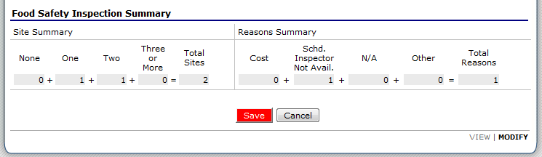

8. If you have any errors, click on the Edit button.
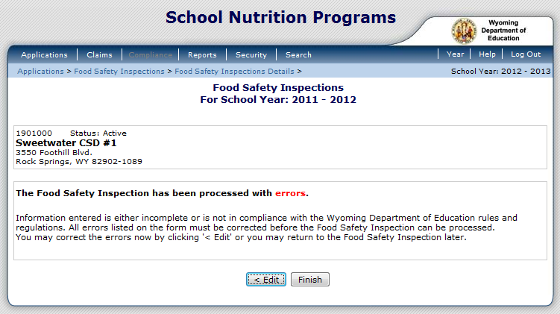

9. Correct the errors listed.
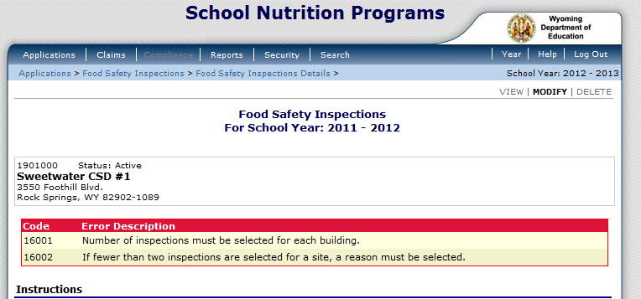

10. Click on Save again. If you have no errors, click on Finish.
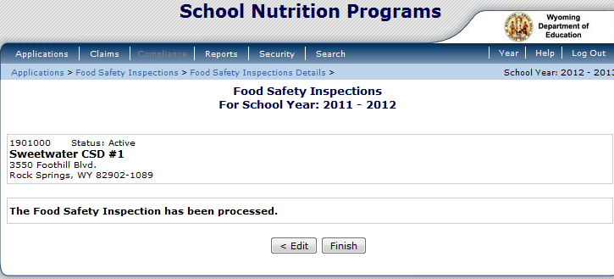

11. Click on Back
