Portion Sizes of Common Fruits and Vegetables
Examples of 1 Cup Servings
1 small apple | 1 large banana | 1 medium grapefruit

1 large orange | 1 medium pear | 1 small wedge watermelon

2 large or 3 medium plums | 8 large strawberries | 1 large bell pepper

1 medium potato | 2 large stalks of celery | 1 cup cooked greens or 2 cups raw spinach or leafy greens

12 baby carrots  (or 2 medium carrots) | 1 large sweet potato | 1 large ear of corn

= = 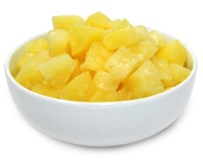
Cooked carrots, canned peaches, canned pineapple
Examples of ½ Cup Servings
1 snack container of applesauce | 16 grapes | 1 medium cantaloupe wedge

1/2 medium grapefruit | 4 large strawberries | 5 broccoli florets

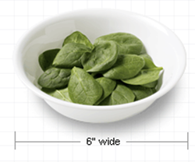

6 baby carrots bottom of a 6” bowl 1 cup spinach or leafy greens

Examples of ¼ Cup Servings
(Counts as ½ Cup)
= = 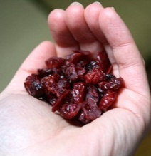
1 small box of raisins size of a golf ball 1 small handful
Examples of ¼ Cup Servings

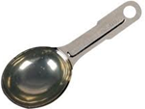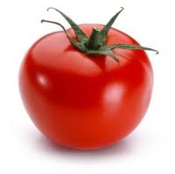
2 tablespoons tomato puree 1 tablespoon tomato paste

References: http://www.choosemyplate.gov/food-groups/ and http://www.fruitsandveggiesmatter.gov/what/examples.html#1cup
Developed by Alta Peila, Dietetic Intern, April 2012
Montana Team Nutrition, http://opi.mt.gov/Programs/SchoolPrograms/School_Nutrition/MTTeam.html, 406-994-5641

Color Your Plates by Varying Your Fruits and Vegetables

Dark Green
    - Bok choy
    - Broccoli
    - Collard greens
    - Dark leafy greens
    - Kale
    - Mustard greens
    - Romaine lettuce
    - Spinach
    - Watercress

Dry Beans and Peas
    - Black beans
    - Black-eyed peas (mature, dry)
    - Garbanzo beans (chickpeas)
    - Kidney beans
    - Lentils
    - Navy beans
    - Pinto beans
    - Soy beans
    - Split peas
    - White beans

  - Starchy
    - Cassava
    - Corn
    - Green bananas
    - Green peas
    - Green lima beans
    - Plantains
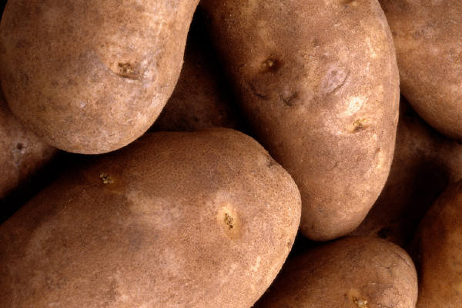
    - Potatoes
    - Water chestnuts

Red & Orange
    - Acorn squash
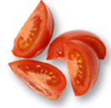
    - Butternut squash
    - Carrots
    - Hubbard squash
    - Pumpkin
    - Red peppers
    - Sweet potatoes
    - Tomatoes
    - Tomato juice

Other
    - Artichokes
    - Asparagus
    - Avocado
    - Bean sprouts
    - Beets
    - Brussels sprouts
    - Cabbage
    - Cauliflower
    - Celery
    - Cucumbers
    - Eggplant
    - Green beans
    - Green peppers
    - Iceberg lettuce
    - Mushrooms
    - Onions
    - Parsnips
    - Wax beans
    - Zucchini

