Anti-bullying grant application

2015

School Safety Initiative
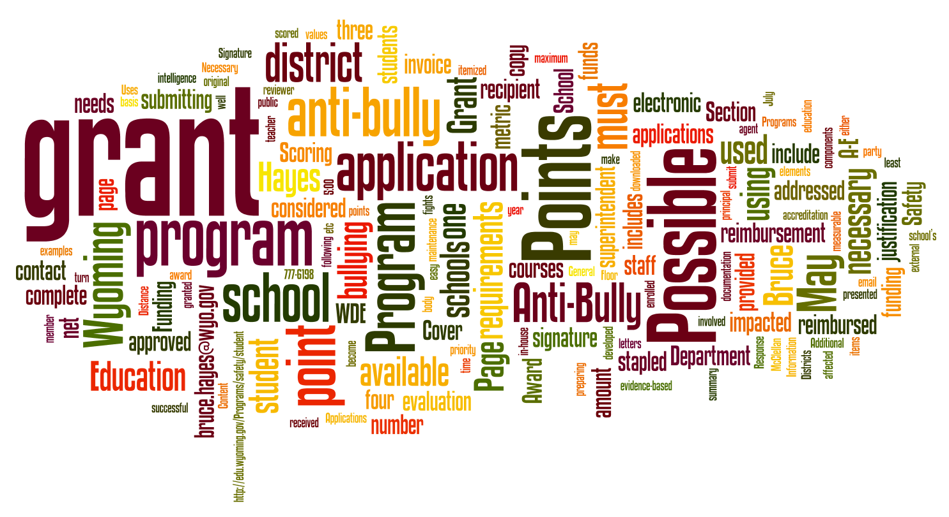

2014 Session Law, Division 1400, Unit 1401

Jillian Balow
State Superintendent of Public Instruction
Wyoming Department of Education
Hathaway Building, Second Floor
2300 Capitol Avenue
Cheyenne, Wyoming 82002-0050

WDE Program Contact:

Bruce Hayes, Program Consultant
Standards and Accountability Division
Phone: 307-777-6198 FAX: 307-777-8924
E-mail: bruce.hayes@wyo.gov

Cover text/graphic generated at http://www.Wordle.net

General Information

Definition of Anti-Bullying Program

An anti-bullying program is considered any program, either provided by an outside third party or developed within a school district, which has the real and measurable net effect of reducing bullying.

Goals for Anti-Bullying Programs

The Wyoming Department of Education (WDE) is helping schools and districts acquire either programmatically mature/evidence-based anti-bullying programs or innovative programs to make the largest positive impact possible in reducing school bullying and increasing positive school climate.

Intended Uses of the Anti-Bullying Grant Funding

- Continue with anti-bullying work started with the 2010, 2011, 2012, 2013, or 2014 School Safety Initiatives
- Start new anti-bullying work in a school or district that did not exist before
- Increase levels of character education that can translate into reduced bullying
- Bring in proven evidence-based best practices to increase school climate
- Start effective innovative programs that are aimed at lowering bullying levels

Eligibility Requirements

Any Wyoming school district may apply for the grant (or a school through its district). It is necessary to have a grant administrator such as a teacher or staff member who is responsible for carrying out or overseeing the work of the grant.

Method of Submission

To be considered for funding, four (4) hard copies must be received by the WDE by the deadline of 5:00 pm (MST) May 28, 2015 addressed to:

Bruce Hayes, School Safety Consultant
Wyoming Department of Education
Hathaway Building, 2nd Floor
2300 Capitol Avenue
Cheyenne, Wyoming 82002-0050

Appendices and additional attachments are not allowed. Each complete application must include:

- Cover Page
- A Response to All Categories [A-C]
- Signature Page

Grant Scoring/Award Process

Scoring of applications is done using the provided rubric by an independent group of internal/external evaluators. Each anti-bullying grant section is scored using the enclosed rubric on page 9.

Regarding page 4 – All information will be checked complete and valid (points may be removed if the basics are incomplete).

A. Program Requested 30 Points Possible
B. Program Justification 30 Points Possible
C. How Funding Will be Utilized 40 Points Possible

Total points per reviewer 100 Points Possible

Funding award letters shall be sent to each (recipient) grant administrator on or about June 5, 2015. The bulk of the summer will be available to align providers for the fall of the 2015-2016 school year. Funds are available to the recipient districts on a reimbursement basis.

At the End of the Grant Period

Districts are reimbursed up to the originally approved grant amount by submitting a single itemized district invoice. This invoice shall be submitted together with the grant final report. Both are due no later than April 29, 2016. A copy of the receipts or other similar documentation must be provided to correlate reimbursement costs.

Each grant final report shall include the following items. In the submitted report, the indicated content shown below shall be aligned to its respective letter:

- Program name, district, grant administrator, and contact information.
- The actual grant amount expended and confirmation that the grant related activities are on the district website so other districts may learn from your experiences.
- The number of students enrolled in the school(s) involved with the grant.
- A summary of how the grant or program impacted the staff and student body.
- At least one metric used in the grant and how the metric values changed over the time the program was in effect (examples: discipline referrals, class disruptions, fights, etc.).
- A two to five page evaluation of how well (or not) the program reduced bullying.

IMPORTANT! The grant invoice submitted without its associated final report is NOT reimbursable!

For WDE Use Only
LEA #:
Award Amount:
Date Approved:

Application

Note: The Anti-Bullying Grant Application is accessible at …
http://edu.wyoming.gov/in-the-classroom/health-safety/facilities-safety/

Cover Page
Application Due to Department: NLT May 28, 2015

Name of Program:
Program Provider:
Provider Address:

Total Student Number Affected:
List Schools Served by Program or Grant:
Name of District

Grant Administrator:
Work Phone Number:
Cell Phone Number:
Work Email Address:
and (Optional) Alternate Email Address:
Mailing Address:

Amount Requested:
($1K to $12K)

Send Four (4) hardcopy applications to:
Bruce Hayes, School Safety Consultant
Support Systems and Resources Division
Phone: 307-777-6198 FAX: 307-777-8924
E-mail: bruce.hayes@wyo.gov

A. Program Requested

Achievement and How it Works: Please fill in the requested information below:

Name of Program:
What the Program Accomplishes:
Target Grades:
How the Program Works:
(Staff training, how program involves students, etc.)
Additional Comments:
(Optional field for additional information)
Program Goals – list two to five: (Recall that a quality goal is a SMART goal; Specific, Measurable, Attainable, Realistic, and Timely)
Program Objectives – list two to six: (Steps to achieve goals)

B. Program Justification

Reasons: In the space below, relate the reasons why you are choosing this program or effort.
Outcomes: Specific outcomes or benefits expected.

C. How Funding Will be Utilized

Narrative: Please describe how the funding will be utilized.

Budget Expenditures: Please itemize specific expenditures. (Add lines if necessary. Total should match amount requested.) |  | Itemized Costs:
Total Program
Cost:

Directions: Please ensure all original signatures are in blue ink.

Signature Page

The undersigned agree and support the implementation of the anti-bullying program as outlined within this grant request.

GRANT ADMINISTRATOR’S NAME SIGNATURE DATE

DISTRICT SUPERINTENDENT’S NAME SIGNATURE DATE

IMPORTANT! A grant application cannot be considered if both signature lines are not filled. Funding is predicated upon receipt of the original signatures.

This rubric describes how the grant will be judged. Higher scores are awarded first. Awards continue downward until the funding runs out. In extenuating circumstances, adjustments can be made either way for very little or highly extended efforts put into the grant application.

Rubric

Program Requested (Max. 30 points. Actual points awarded for each row will be interpolated

on a graduated scale from 0 to 10 depending on the number/quality of successfully included provisions.)

(0-10 Points)  ___________ | 10 Points – Program requested information is complete and easy to understand. | 0 Points – Program requested information is significantly incomplete and difficult to understand.
(0-10 Points)  ___________ | 10 Points – Program goals are SMART goals, well explained, and sufficient in number. | 0 Points – Program goals are not SMART goals, difficult to categorize, and insufficient in number.
(0-10 Points)  ___________ | 10Points – Program objectives are present, explained, and linked to the goals. | 0 Points – Some material is listed, but cannot fully be interpreted as objectives.

Program Justification (Max. 30 points. Actual points awarded for each row will be interpolated

on a graduated scale from 0 to 15 depending on the number of successfully included provisions.)

(0-15 Points)  ___________ | 15 Points – The “reasons” narrative is compelling, realistic, strongly linked to anti-bully strategy, easy to read, and supported by facts. | 0 Points – A small number of things are listed that cannot be fully interpreted as supporting justification.
(0-15 Points)  ___________ | 15 Points – At least three outcomes are listed, strong, and aligned to the narrative. | 0 Points – Itemized outcomes are too few and difficult to relate to anti-bullying.

How funding Will be Utilized (Max. 40 points. Actual points awarded for each row will be

interpolated on a graduated scale from 0 to 20 depending on the number of successfully included provisions.)

(0-20 Points)  ___________ | 20 Points – The narrative on how the funding will be used is clearly written and deemed effective towards achieving anticipated results. | 0 Points – The small number of things listed cannot easily be interpreted as narrative items regarding how the funding will be used.
(0-20 Points)  ___________ | 20 Points – Specific expenditures are align to the narrative, are pertinent, clear, easy to read, and the itemized costs are correctly totaled. | 0 Points – There is a weak level of clarity in what is listed as specific expenditures. Itemized costs do not add up.

Definitions

Program – A named and packaged set of actions and training elements that typically exists outside the standard school curriculum, which is designed to accomplish a specific goal in schools.

Outside third party – A provider of services, either for-profit or non-profit, that is not employed with the
school, district, or the state.

Programmatically mature – A program that has already been proven to be effective and is used frequently in the field.

Evidence-based – A term often applied to education programs that tell the public a given program is studied and
that concrete data exists to indicate the effectiveness of the program in actual school settings.

Innovative programs – Programs that are relatively new, or that may have unconventional elements to their mechanics or theories, but have garnered the support of the school administration for various reasons as worthy of implementation.

