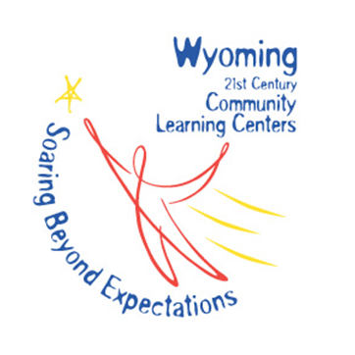
Programming Modification Request
21st Century Community Learning Centers

Please return completed form to:

Karen Bierhaus, 21 CCLC Program Manager
Wyoming Department of Education
320 West Main St, 2nd Floor
Riverton, WY 82501
karen.bierhaus@wyo.gov

Cohort Designation
Budget Fiscal Year:
Cohort: |  |  | 5th Cohort |  | 6th Cohort |  | 7th Cohort
21st Century Grantee:
Name of Lead Agency:
Address:
City: |  | State: |  |  |  | Zip:
Phone: |  |  |  | Fax:
Contact Information
Name of Person Completing Report:
Title:
Agency:
Phone: |  |  |  | Fax:
Email Address:
I approve the changes requested in the modification. You may type and send electronically or sign
and scan request.
Name: Date:

For Administrative Use Only
Date Received
Date of Response
Approved Yes No
Comments

Approved By
Signature

Programming Modification Explanation

Please give details where appropriate to expedite approval process.

- Are you adding a new program?
Yes No

- If you are adding a new program, please describe it.

- Is this program research-based?
Yes No

- How often will this program be offered?
1 Time/Week
2 Times/Week
3 Times/Week
4+ Times/Week

- What centers will this program be provided at?

- Are you removing a program?
Yes No

- Which program(s) are you removing?

- Why are you removing this program?

- Will removing this program affect hours of service?
Yes No

- Please describe how service hours will be affected?

- How many regular attendees will be impacted by this programming modification?

- Has your Community Advisory Board formally approved this change request?
Yes No

If no, why is the request being submitted?

- Will this change in programming affect your budget?

Yes No

If yes, please a complete a Budget Modification and submit with this Program Modification. The budget modification must be approved before funds can be expended under this program modification for any new/additional purposes.

