**Instructions for Determining Eligibility Based on Census Data**

**Step 1: Become familiar with the census data format**

About the 2010 Census Block Group

Every 10 years, the Census updates the area-based measures such as census tracts, blocks and block groups. CACFP, SFSP and SSO use both census tracts and block groups to determine area eligibility.

01

001

020100

1

The ideal size of a CBG is around 1500 homes but vary by region and area characteristics. Contrary to the name, CBGs are not usually shaped like rectangles; rather they can take any shape. The graphic on the left shows the relationship of CBGs to other geographical areas and the components of the GEOID.

Every CBG in the country is numerated, meaning it has a unique number assigned to it. This number is called the GEOID.

What information is in the GEOID?

The GEOID contains 12 digits. Each position in the GEOID signifies a different level of geographical area. Every digit is important, even the first zero. This is important to remember when importing these data, because some programs drop the first zero. There is more information below about how to import the data correctly.

Here is an example of a GEOID from Autauga County, Alabama:

010010201001

* **STATE**:  The first 2characters are the State code
* **COUNTY**:  The next 3-characters are the county code
* **TRACT**:  The next 6-characters are the census tract code
* **BLOCK GROUP:**  The last character is the census block group code

**Step 2: Determine eligibility**

Below are instructions for two options to determine eligibility. State agencies, sponsoring organizations, and individuals may use either tool.

1. The FNS Map. This map includes an address search that will return eligibility information as well as other demographics. This map also includes zoom capabilities and map comparison for identifying areas of need.
2. The Food Research and Action Center (FRAC) Map. These tools provide another method of identifying eligibility. There is one map for CACFP and one for SFSP and SSO but either map may be used to determine eligibility for both programs.

**Step 2, Option 1: Determining eligibility using the FNS Area Eligibility Mapper**

Go to: http://www.fns.usda.gov/areaeligibility

1. To find by address, enter the address in the “Find address or place” box in the top right.
2. Zoom in and out of the map using the (+) and (-) signs, respectively.
3. In the resulting map, the red highlighted color indicates eligibility as noted in the map layer key.
4. A larger map is available by clicking “View Larger Map” at the bottom of the screen.

**Step 2, Option2: Determining eligibility using the 2014 FRAC Summer Food Mapper**

1. Go to either FRAC map:
   1. CACFP http://216.55.182.132/FairData/CACFP/map.asp?command=scope&map=0
   2. SFSP and SSO http://216.55.182.132/FairData/SummerFood/map.asp?command=scope&map=0
2. To find by address, click on “Find” and enter the address.
3. In resulting map, the highlighted color indicates eligibility as indicated in the map layer key.
4. 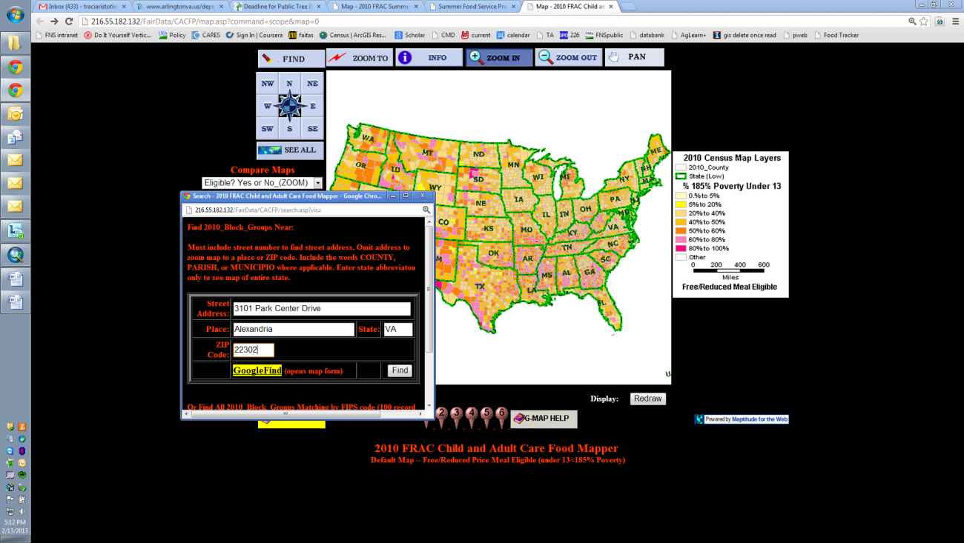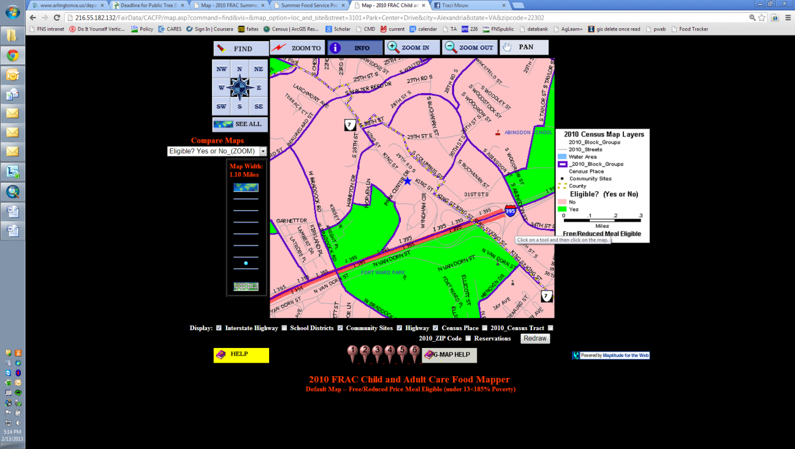If an address falls on a border between an eligible and ineligible CBG, click on the blue star and then INFO and scroll in the “2010 Block Group Information” window to “Eligible? (Yes or No).

**Step 2, Option 3: Combining CBGs:**

With both State agency and FNS Regional Office (RO) approval, areas that are ineligible using the method above may be eligible through a third method. Up to three adjacent CBGs where at least

40 percent or more of the children in each CBG are eligible for free or reduced-price meals may be combined to determine eligibility. If combining the adjacent CBGs results in a weighted average of 50 percent or more free and reduced-price eligible, the CBG can be considered eligible.

Averaging adjacent CBGs is meant to address pockets of poverty near census eligible CBGs. In other words, this method allows for the area around a day care home or summer site to be expanded to address nearby areas of high need.

In order to properly calculate the weighted average, it is important that:

* Only up to three CBGs are averaged, and one of these must include the CBG where the day care home or summer site is located.
* All CBGs included in the weighted average have 40 percent or more children eligible for free or reduced-price meals
* The CBGs are adjacent to, or share a border with the CBG where the day care home or summer site is located.
* Either data for CACFP (0-12 year olds) or SFSP and SSO (0-18 year olds) is used to determine the weighted average. Either of these numerators and denominators may be used to determine eligibility using the weighted average but the same data set must be used across CBGs.

Instructions for using the FNS Mapper:

1. Follow the instructions above to find the location of the day care home or SFSP or SSO site.
2. Click on the ineligible CBG and determine if at least 40 percent or more of the children in each of the CBGs to be combined are eligible for free and reduced-price meals by dividing either:
   1. the Num18pov (Numerator) /Total18inBG (Denominator); or
   2. the Num12pov (Numerator)/ Total12inBG (Denominator)

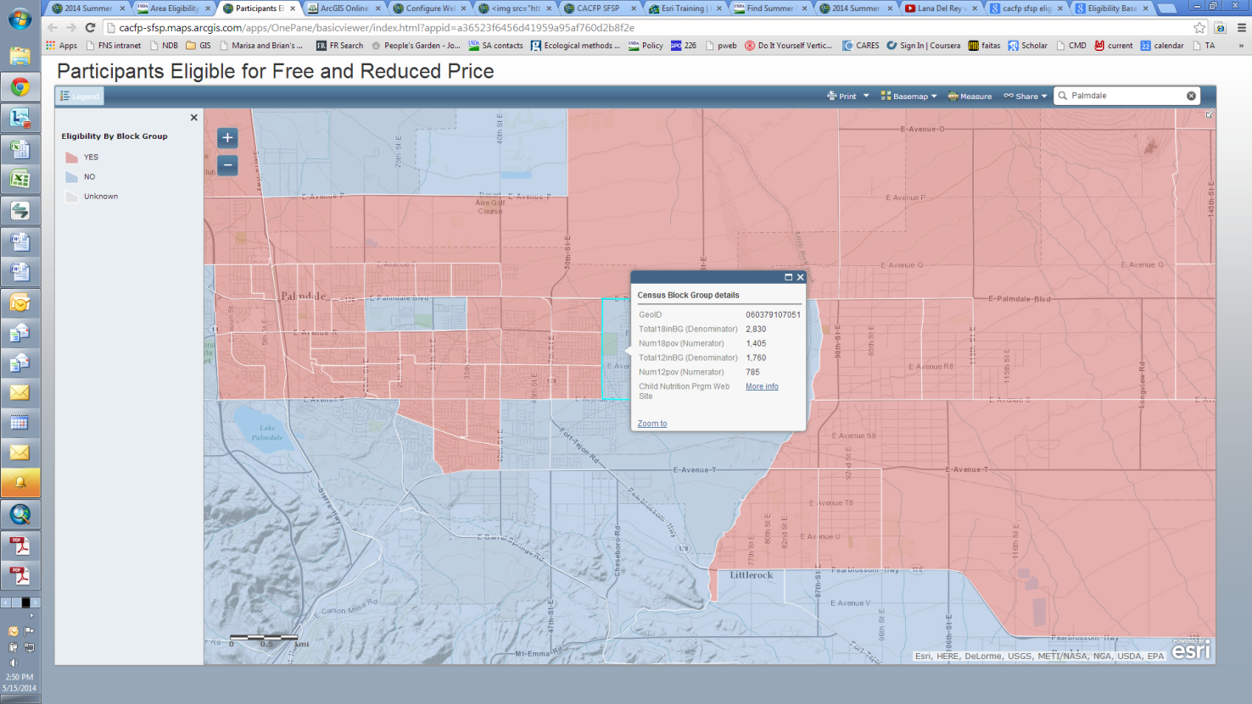

These fields represent the number of 0-18 year olds and the number of 0-12 year olds in the CBG

1. If at least 40 percent or more of the children in each of the combined CBGs are eligible for free and reduced-price meals, then proceed with the weighted average by:
   1. Adding the numerators for the CBG where the site is located, and up to two additional adjacent CBG’s with over 40 percent free or reduced-price eligibility. Determine if the adjacent CBGs have at least 40 percent eligibility by using the method in step 2 above.
   2. Adding the denominators in the same way.
   3. Dividing the sum of the numerators by the sum of the denominators and multiplying by 100%. If that percentage is 50 percent or above the CBG can be considered area eligible with FNS RO and State agency approval.

**Example:**

|  |  |  |  |  |
| --- | --- | --- | --- | --- |
| Palmdale, California |  |  |  | |
| CBG GEOID | Numerator (Num18Pov) | Denominator (Total18inBG) | Percentage (Numerator/Denominator) x 100%  *must be at least 40%) | |
| 60379107051 | 1,405 | 2,830 | x 100% | 49.65% |
| 60379107131 | 435 | 680 | x 100% | 63.97% |
| 60379107141 | 855 | 955 | x 100% | 89.53% |
| Total | Sum of Numerators (1405+435+855) | Sum of Denominators  (2830+680+955) | Weighted average percent = (Sum of Numerators)/(Sum of Denominators) x 100% | |
|  | 2,695 | 4,465 | x 100% | 60.36% |