Anti-bullying grant application

2014

School Safety Initiative
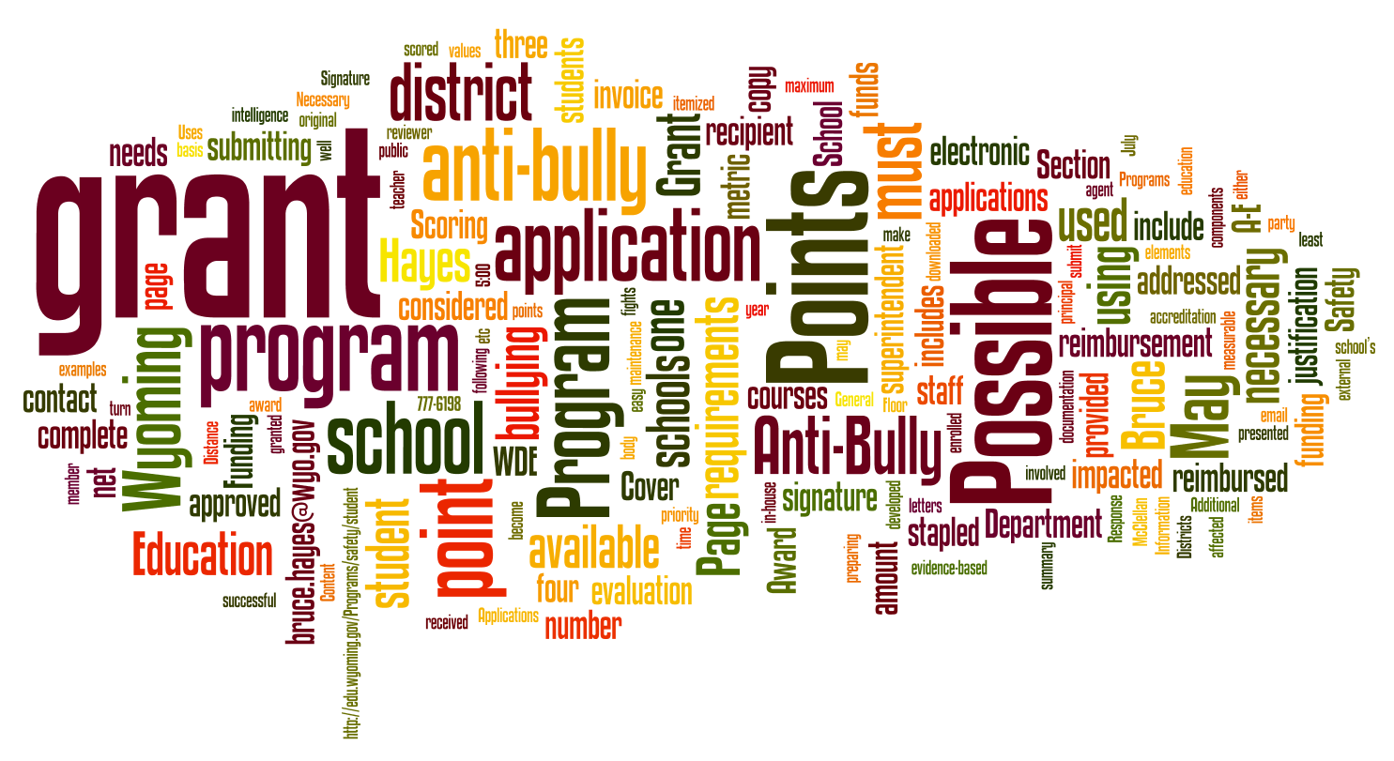

2014 Session Law, Division 1400, Unit 1401

Cindy Hill
State Superintendent of Public Instruction
Wyoming Department of Education
Hathaway Building, Second Floor
2300 Capitol Avenue
Cheyenne, Wyoming 82002-0050

WDE Program Contact:

Bruce Hayes, Program Consultant
Support Systems and Resources Division
Phone: 307-777-6198 FAX: 307-777-8924
E-mail: bruce.hayes@wyo.gov

Cover text/graphic generated at http://www.Wordle.net/

TABLE OF CONTENTS

Section I: General Information 2

Definition of anti-bullying Programs 2
Goals for Anti-bullying Programs 2
Intended Uses of the Anti Bullying Grant Funding 2
Eligibility Requirements 2
Method of Submission 2
Grant Scoring and Award Process/at end of grant period 3

Section II: Application Forms 4

A. program Requested 5
B. Program Justification 6
C. How funding will be used 7
D. Program history 8
Signature Page …………………………………………………………………………………………………………………………………………………… 9

Section Iii: Grant scoring Rubric 10

A. program requested 10
B. program justification 10
C. how funding will be used 11
D. Program history 11
appendix 12

OPPORTUNITY FOR A HEARING

An applicant whose application is recommended for disapproval may request a hearing before the State Superintendent of Public Instruction or designee. Formal written notification requesting such a hearing must be submitted within thirty (30) calendar days of receipt of notice that the application is recommended for disapproval to:

Cindy Hill
State Superintendent of Public Instruction
Wyoming Department of Education
Hathaway Building, Second Floor
2300 Capitol Avenue
Cheyenne, Wyoming 82002-0050

The Wyoming Department of Education does not discriminate on the basis of race, color, national origin, sex, age, or disability in admission or access to, or treatment or employment in its educational programs or activities. Inquiries concerning Title VI, Title IX, Section 504, and the Americans with Disabilities Act may be referred to the Wyoming Department of Education, Office for Civil Rights Coordinator, Hathaway Building, Second Floor, 2300 Capitol Avenue, Cheyenne, Wyoming 82002-0050, or the Office for Civil Rights, Region VIII, U.S. Department of Education, Federal Building, Suite 310, 1244 Speer Boulevard, Denver, Colorado 80204-3582, or 303-844-5695 or TDD 303-844-3417. This publication will be provided in an alternative format upon request.

Section I: General Information

Definition of Anti-Bullying Program

An anti-bullying program is considered any program, either provided by an outside third party or developed within a school district, that has the real and measurable net effect of reducing bullying.

Goals for Anti-Bullying Programs

The Wyoming Department of Education (WDE) is helping schools and districts acquire either programmatically mature/evidence-based anti-bullying programs or innovative programs to make the largest positive impact possible in reducing school bullying and increasing positive school climate.

Intended Uses of the Anti-Bullying Grant Funding

- Continue with anti-bullying work started with the 2010, 2011, 2012, or 2013 School Safety Initiatives
- Start new anti-bullying work in a school or district that did not exist before
- Increase levels of character education that can translate into reduced bullying
- Bring in proven evidence-based best practices to increase school climate
- Start effective innovative programs that are aimed at lowering bullying levels

Eligibility Requirements

Any Wyoming school district may apply for the grant (or a school through its district). It is necessary to have a grant administrator such as a teacher or staff member who is responsible for carrying out or overseeing the work of the grant.

Method of Submission

To be considered for funding, four (4) hard copies must be received by the WDE by the deadline of 5:00 pm (MST) June 6, 2014 addressed to:

Bruce Hayes, School Safety Consultant
Wyoming Department of Education
Hathaway Building, 2nd Floor
2300 Capitol Avenue
Cheyenne, Wyoming 82002-0050

Appendices and additional attachments are not allowed. Each complete application must include:

- Cover Page
- A Response to All Award Categories [A-D]
- Signature Page

Grant Scoring/Award Process

Scoring of applications is done using the provided rubric by an independent group of internal evaluators.
Each anti-bullying grant section is scored and evaluated using the rubric presented in Section III:

Page 4 – All information will be checked complete and valid (points may be docked if the basics are incomplete!).

A. Program Requested 20 Points Possible
B. Program Justification 20 Points Possible
C. How Funding Will be Used 40 Points Possible
D. Program History 20 Points Possible

Total points per reviewer 100 Points Possible

Funding award letters shall be sent to each applicant’s grant administrator on or about June 23, 2014. The bulk of the summer will be spent aligning providers for the fall or the 2014-2015 school year. Funds are available to the grant recipient’s district on a reimbursement basis. No work done prior to July 1, 2014 is reimbursable.

At the End of the Grant Period

Districts are reimbursed up to the originally approved grant amount by submitting a single itemized district invoice. This invoice shall be submitted together with the grant final report. Both are due no later than May 29, 2015. A copy of the receipts or other similar documentation must be provided to correlate reimbursement costs.

Each grant final report shall include the following items. In the submitted report, the indicated content shown below shall be aligned to its respective letter:

- Program name, district, grant administrator, and contact information.
- The actual grant amount expended and confirmation that the grant related activities are on the district website so other districts may learn from your experiences.
- The number of students enrolled in the school(s) involved with the grant.
- A summary of how the grant or program impacted the staff and student body.
- At least one metric used in the grant and how the metric values changed over the time the program was in effect (examples: discipline referrals, class disruptions, fights, etc.).
- A two to five page evaluation of how well (or not) the program reduced bullying.

IMPORTANT! The grant invoice submitted without its associated final report is NOT reimbursable!

Section II: Application Forms
Note: The Anti-Bullying Grant Application is accessible at …
http://edu.wyoming.gov/in-the-classroom/health-safety/facilities-safety/

Cover Page
Application Due to Department: NLT June 6, 2014

Name of Program:
Program Provider:
Provider Address:

Total Student Number Affected:
List Schools Served by Program or Grant:
Name of District

Grant Administrator:
Work Phone Number:
Cell Phone Number:
Work Email Address:
and (Optional) Alternate Email Address:
Mailing Address:

Amount Requested:
($5K to $9K)

Send Four (4) hardcopy applications to:
Bruce Hayes, School Safety Consultant
Support Systems and Resources Division
Phone: 307-777-6198 FAX: 307-777-8924
E-mail: bruce.hayes@wyo.gov

For WDE Use Only
LEA #:
Award Amount:
Date Approved:

A. Program Requested

Directions: Please fill in the requested information below including any (optional) additional comments that are helpful for the review team to know about your application. Also please list the relevant program goals and objectives (Recall that a quality goal is a SMART goal; Specific, Measurable, Attainable, Realistic, and Timely).

Name of Program:
What the Program Accomplishes:
Target Grades:
How the Program Works:
(Training staff, involves students, etc.)
Additional Comments:
(Optional field for additional information)
Program Goals (At least two (2), no more than five (5)):
Program Objectives (Steps to achieve goals):

B. Program Justification

Directions: Please justify the need for the proposed program in two ways below. In the first section, list the reasons why you are choosing this program. In the second section, list any specific benefits or outcomes that you expect from this program.
Outcomes: Itemize specific outcomes or benefits expected.
1.
2.
3.
4.
5.

C. How Funding Will be Used

Directions: Please describe how the funding, if awarded, will be utilized. In addition, itemize the major program expenditures (training, materials, etc.) that will be incurred during the school year or length of the program.
Budget Narrative: Itemize specific expenditures described in the goals narrative above. (Add lines if necessary. Total should match amount requested.) |  | Itemized Costs:
Total Program
Cost:

D. Program History (Answer either box 1 or box 2)

Box 1 Directions: Please describe how the program is evidence-based. Does the grant build on what was done via the 2012 or 2013 School Safety Initiative? If so, how?

Box 2 Directions: Please explain how the program is innovative. What features of the program make it worth trying? Does the grant build on what was done via the 2012 or 2013 School Safety Initiative? If so, how?

Directions: Please ensure all signatures are in blue ink.

Signature Page

The undersigned agree and support the implementation of the anti-bullying program as outlined within this grant request.

GRANT ADMINISTRATOR’S NAME SIGNATURE DATE

DISTRICT SUPERINTENDENT’S NAME SIGNATURE DATE

IMPORTANT! A grant application cannot be considered if both signature lines are not filled. Funding is predicated upon receipt of the original signatures.

This rubric describes how the grant will be judged. Higher scores are awarded first. Awards continue downward on the point scale until the funding runs out.

Section III: Rubric

A. Program Requested (Maximum 20 points)
(0-6 Points)  ___________ | 6 Points – The program information is complete. | 4 Points – Some minor program information is missing. | 2 Points– Several lines of program information is missing. | 0 Points – No Program Information is present.
Reader Comments:

(0-7 Points)  ___________ | 7 Points – Program goals are SMART goals, well explained, and sound. | 4 Points – Goals are explained, but some questions exist on what is trying to be achieved. | 2 Points – Goal listing is weak. | 0 Points – No program goals are listed at all.
Reader Comments:

(0-7 Points)  ___________ | 7 Points – Program objectives are present, well explained, and linked to the goals. | 4 Points – One or two program objectives are present. Some questions exist regarding how the objectives relate to the goals. | 2 Points – Some material is listed that cannot fully be interpreted as objectives. | 0 Points – No program objectives are listed at all.
(Reader Comments:

B. Program Justification (Maximum 20 points)
(0-14 Points)  ___________ | 14 Points – The narrative is compelling, realistic, strongly linked to anti-bully strategy, easy to read, and supported by facts. | 9 Points – The narrative is adequate – somewhat linked to strategy, but causes occasional questions. | 5 Points – A small number of things are listed that cannot be fully interpreted as narrative points. | 0 Points – There is no narrative stated.
Reader Comments:

(0-6 Points)  ___________ | 6 Points – Specific outcomes are listed linked to the narrative. | 4 Points – Program outcomes are listed but contain some ambiguity. | 2 Points – A small number of things are listed that cannot all be interpreted as program outcomes. | 0 Points – There are no itemized outcomes listed.
Reader Comments:

C. How Funding Will be Used (Maximum 40 points)
(0-20 Points)  ___________ | 20 Points – The narrative on how the funding will be used is deemed effective towards achieving anticipated results. | 13 Points – The narrative is somewhat effective towards achieving expected outcomes. | 5 Points – A small number of things are listed that cannot easily be interpreted as narrative points regarding how the funding will be used. | 0 Points – There is no narrative listed.
Reader Comments:

(0-20 Points)  ___________ | 20 Points – Specific expenditures are crisp, clear, easy to read, and the itemized costs are correctly totaled. | 13 Points – Specific expenditures are listed but there are questions and a math error(s) in the addition. | 5 Points – There is a moderate level of ambiguity in what is listed as specific expenditures. | 0 Points – There are no specific expenditures listed.
Reader Comments:

D. Program History (Grade only the box that applies to the applicant) (Maximum 20 points)
(0-20 Points)  ___________  Box 1 | 20 Points – The program is clearly an evidence-based best practice, has a proven history, and builds on what has been done before in the district. | 13 Points – There is some ambiguity regarding the best practice status. | 5 Points – It is somewhat unclear how the program would support the cause of the school. | 0 Points – The program support issues are not stated.
Reader Comments for Box 1:

or
(0-20 Points)  ___________  Box 2 | 20 Points – The district makes an excellent case for trying an innovative program, aligns to student needs, and builds on what has been done before in the district. | 13 Points – The district gives only general support for trying an innovative program. | 5 Points – There is ambiguity regarding how the new program would serve students. | 0 Points – The program support issues are not stated.
Reader Comments for Box 2:

Appendix

Definitions
Program – A named and packaged set of actions and training elements that typically exists outside the standard school curriculum, which is designed to accomplish a specific goal in schools by various means.

Outside third party – A provider of services, either for-profit or non-profit, that is not employed with the
school, district, or the state.

Programmatically mature – A program that has already been proven to be effective and is used frequently in the field.

Evidence-based – A term often applied to education programs that tell the public a given program is studied and
that concrete data exists to indicate the effectiveness of the program in actual school settings.

Innovative programs – Programs that are relatively new, or that may have unconventional elements to their mechanics or theories, but have garnered the support of the school administration for various reasons as worthy of implementation.

