**Purchasing**

**Resource Guide**

**For Farm to School in Wyoming**

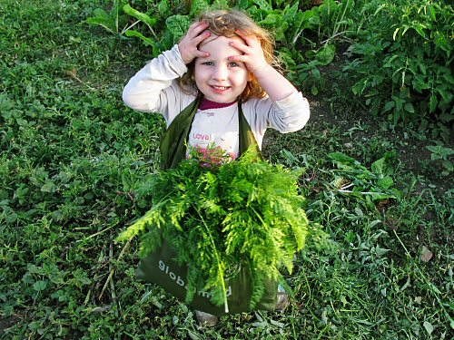

WHO WE ARE

**Wyoming Department of Agriculture**

Website: <http://agriculture.wy.gov/>

Brook Brockman, Ag Education Coordinator  
Wyoming Department of Agriculture  
Phone: 307-777-5612  
[brook.brockman@wyo.gov](mailto:brook.brockman@wyo.gov)

Wyoming Department of Education

Wyoming Department of Education Farm to School

Website: <http://edu.wyoming.gov/Programs/nutrition/Farm_to_School.aspx>

Susan Benning, Accountant  
Wyoming Department of Education  
Phone: 307-777-6280  
[susan.benning@wyo.gov](mailto:susan.benning@wyo.gov)

Terry Walling, National School Lunch Program Consultant

Wyoming Department of Education

Phone: 307-777-6270

[terry.walling@wyo.gov](mailto:terry.walling@wyo.gov)

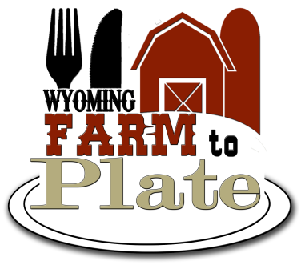

“In accordance with Federal law and U.S. Department of Agriculture policy, this institution is prohibited from discriminating on the basis of race, color, national origin, sex, age, religion, political beliefs, or disability.

To file a complaint of discrimination, write USDA, Director, Office of Civil Rights, 1400 Independence Avenue, S.W., Washington, D.C. 20250-9410 or call (800) 795-3272 (voice) or (202) 720-6382 ( TTY). USDA is an equal opportunity provider and employer."

Published April 2013

Table of Contents

Purchasing Locally Grown Food

Why Do Business With Local Producers?4

Direct from Producers4

Creating a Successful Farm to School Program 4

Strategies for Success5

Channels for Purchasing Locally Grown Good

Finding Local Foods 6

Finding Fresh Produce6

Producers Markets 7

Procuring Local Foods7

What Agricultural Products Qualify for the Use of a Geographic Preference8

Common Misconceptions about Procuring Food for Farm to School8

Understanding the Regulations that Guide Purchasing Local Food

Food Safety 10

Meat12

Poultry12

Dairy Products12

Eggs 12

Produce12

Liability Insurance Requirements13

Procurement

Additional Procurement Considerations 14

Procurement Options15

Informal Procurement Method 15

Formal Procurement Method16

Developing Product Specifications16

Attachments

Sample Vendor Letter 19

Specification Worksheet20

Product Availability and Pricing 22

Sample Simple Bid Sheet with Scoring24

Sample New Producer Meeting Checklist26

Attachment #1-Producer Survey

Attachment #2-Producer Checklist

Purchasing Locally Grown Food

Why Do Business With Local Producers?

* Local food offers exceptional quality.
* Buying locally supports the economic viability of communities by keeping money cycling locally.
* Schools can help protect the environment by reducing the distance products travel and the amount of fuel being used for transportation costs.
* Producers are knowledgeable about their crops, farming techniques, market trends, and agricultural history.
  + They can be excellent contributors to the educational experience of students.
* Hands-on classroom learning opportunities such as school gardens, recycling, and composting programs can fit into academic requirements.
* Local farms are a great resource for field trips, taste test samples, and school gardens.
* Farm to School can make school nutrition work more fun and satisfying.
* Knowing that you’ve supported local producers and of­fered students delicious, fresh food brings job satisfac­tion to a new level.

**Direct from Producers**

* Shortens the supply chain by cutting out middle man
* Can reduce product cost
* Can reduce fuel costs
* Build relationships by talking directly with producers about growing specifications

**Practical Advice for Food Service Directors: Creating a Successful Farm to School Program**

**Start Small.** A simple way to begin is add one or two easy changes to the school menu. Serving sweet potatoes, lettuce, local eggs or local meat for one meal at one school is the way some school districts start. Small steps count! They help establish relationships with producers and let both sides put “a toe in the water” to see how delivery, paper­work, and packing work.

**Start talking.** It’s important for producers and food service directors to meet, get to know each other, and understand each other’s needs and constraints. Inviting local producers for a meeting at the school cafete­ria is a good way to start.

**Work through existing distributors.** In addition to working with local producers, you can ask current distributors if they offer any local products. More and more food distributors are offering locally grown foods; you may just have to ask for them. The more the large distributors hear requests for locally sourced food, the more likely they are to get on board.

**Tell everyone.** Tell everyone about what you’re doing. That includes school board members, the superinten­dent, teachers, parents, students, the mayor, and the media. Invite community leaders to lunch.

**Engage students in promotion.** Invite art and pho­tography classes to make posters. Ask music classes to write songs and raps. Encourage English classes to write poems, articles, and stories. Theater departments can do skits. Use the announcement system to advertise.

**Strategies for Success**

Farm to School projects vary greatly by region, by community, even by school district. However, a variety of key components are inherent in most farm-to-school initiatives. Using a combination of strategies may help you develop a strong and sustainable foundation for farm-to-school in your area.

* Assess need for additional resources and have adequate funding.
* Commit to a cooperative approach with key partners including producers, food service managers, school administrators, teachers, parents, and students in early planning discussions.
* Start small, build on success, and encourage project partners to join at their pace.
* Organize product supply; develop contact with farmer organizations, grower networks, cooperatives, and/or distributors.
* Work to develop a strong educational component aimed at increasing children’s understanding and acceptance of new foods and menu formats.
* Commit to healthful foods for students that model positive choices and reflect the sound nutritional advice they receive in the classroom.
* Build policy support at the state, local, or district level for ongoing farm-to-school programming.
* Be patient and solve problems creatively; be willing to experiment.
* Communicate thoroughly, honestly, and as frequently as needed. Be sure to include all relevant partners and collaborators in important decisions.
* Promote your project through appropriate avenues such as the local media to build community awareness and support over time.
* Learn from the experiences of established programs. Share these examples with your key partners.

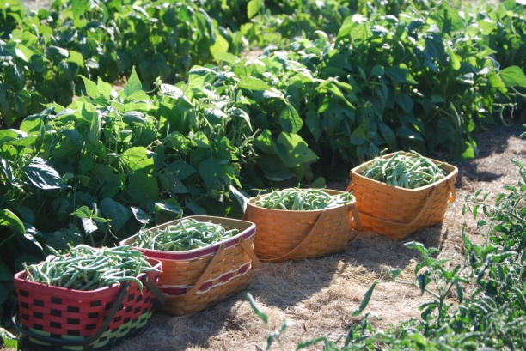

**Channels for Purchasing Locally Grown Food**

**Finding Local Foods**

Perhaps the most challenging aspect of implementing a Farm to School program is sourcing local foods. There are many ways to find and take delivery of local products. Whichever methods are chosen, they should meet the needs of both your school food service and the local producers involved in order to be sustainable over the long term.

* The Wyoming Department of Agriculture can assist you in finding and contacting local producers.
* UW Extension; Eat Wyoming, local food database and information.
* The USDA Farm to School FNS Policy webpage provides food procurement information and links.

**Finding Fresh Produce**

* The Fresh Fruit and Vegetable Program (FFVP) is administered nationally by the U.S. Department of Agriculture’s Food and Nutrition Service and in Wyoming by the State Department of Education. The program seeks to increase school access to fresh fruits and vegetables.
  + The USDA FFVP Page: [www.fns.usda.gov/cnd/ffvp/](http://www.fns.usda.gov/cnd/ffvp/)
  + The Wyoming Department of Education FFVP page: [edu.wyoming.gov/Programs/nutrition/fresh_fruit_and_vegetable_program.aspx](http://edu.wyoming.gov/Programs/nutrition/fresh_fruit_and_vegetable_program.aspx)
* The DoD Fresh Fruit and Vegetable Program (DoD Fresh) is sponsored by the Department of Defense. The program works to bring schools a greater variety of fresh produce.
  + The USDA DoD Fresh page: [www.fns.usda.gov/fdd/programs/dod/default.htm](http://www.fns.usda.gov/fdd/programs/dod/default.htm)
* Farmers markets are a source of fresh and locally grown products.
  + Listing of farmers markets in Wyoming: [www.wyomingfarmersmarkets.org/List_of_WY_Farmers_Markets.pdf](http://www.wyomingfarmersmarkets.org/List_of_WY_Farmers_Markets.pdf)
  + The Wyoming Business Council’s farmers market page: [www.wyomingbusiness.org/program/farmers-markets/1302](http://www.wyomingbusiness.org/program/farmers-markets/1302)
* The University of Wyoming Extension’s Eat Wyoming website provides a local food database and information:[www.wyomingextension.org/eatwyoming/index.asp](http://www.wyomingextension.org/eatwyoming/index.asp%20)

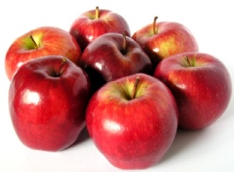

**Producers Markets**

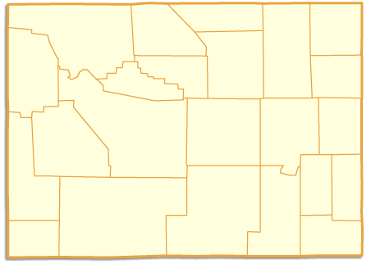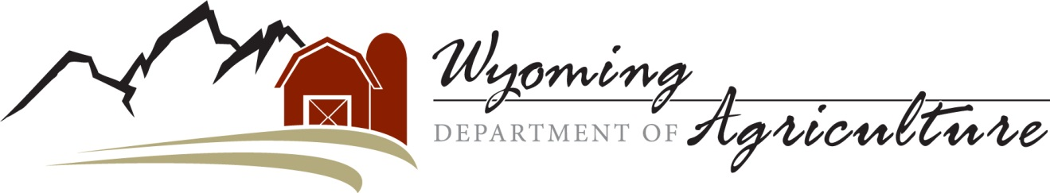

Wyoming

State Inspected

Meat Plants

Rogers Meat

Powell 754-2577

**LEGEND**

**County Name**

**Processing plant and phone number**

**Consumer Health Services (CHS)**

◻ Reduces the occurrences of food safety hazards.

◻ Reduces the occurrences of hazards to health & safety that are created by interaction of the public

◻ HACCP (Hazard Analysis Critical Control Point) trainings

Wyoming Department of Agriculture

2219 Carey Avenue

Cheyenne, WY 82002

(307) 777-7321

*http://agriculture.wy.gov*

**Park**

**Teton**

**Sublette**

**Hot Springs**

**Washakie**

**Big Horn**

**Fremont**

**Uinta**

**Lincoln**

**Sweetwater**

**Carbon**

**Albany**

**Natrona**

**Johnson**

**Campbell**

**Converse**

**Crook**

**Weston**

**Niobrara**

**Platte**

**Goshen**

**Laramie**

Cody Meats

Cody 587-5447

R&B Meats

Green River 875-2556

Jackson Hole Buffalo

Jackson 733-8343

Broschettos European Market

Rock Springs 382-2350

Riverton Packing

Riverton 856-3838

Wyoming Custom Meats

Hudson 332-3655

Wind River Processing

Thermopolis 864-9331

Paint Rock Processing

Hyattville 469-2343

**Sheridan**

Kompac Meat

Casper 234-2626

Weinrichs Quality Meats

Casper 237-2559

Grizzly Slaughter

Douglas 351-4806

Dans Meat Processing

Evansville 235-3157

Kelly Packing Co.

Torrington 532-2210

University of Wyoming

Laramie 766-4163

Home on the Range

Cheyenne 778-8036

Lanes Meat & Sausage

Worland 347-8285

Clarks Meat House

Riverton 856-9700



Wyoming

State Inspected

Meat Plants

Rogers Meat

Powell 754-2577

**LEGEND**

**County Name**

**Processing plant and phone number**

**Consumer Health Services (CHS)**

◻ Reduces the occurrences of food safety hazards.

◻ Reduces the occurrences of hazards to health & safety that are created by interaction of the public

◻ HACCP (Hazard Analysis Critical Control Point) trainings

Wyoming Department of Agriculture

2219 Carey Avenue

Cheyenne, WY 82002

(307) 777-7321

*http://agriculture.wy.gov*

**Park**

**Teton**

**Sublette**

**Hot Springs**

**Washakie**

**Big Horn**

**Fremont**

**Uinta**

**Lincoln**

**Sweetwater**

**Carbon**

**Albany**

**Natrona**

**Johnson**

**Campbell**

**Converse**

**Crook**

**Weston**

**Niobrara**

**Platte**

**Goshen**

**Laramie**

Cody Meats

Cody 587-5447

R&B Meats

Green River 875-2556

Jackson Hole Buffalo

Jackson 733-8343

Broschettos European Market

Rock Springs 382-2350

Riverton Packing

Riverton 856-3838

Wyoming Custom Meats

Hudson 332-3655

Wind River Processing

Thermopolis 864-9331

Paint Rock Processing

Hyattville 469-2343

**Sheridan**

Kompac Meat

Casper 234-2626

Weinrichs Quality Meats

Casper 237-2559

Grizzly Slaughter

Douglas 351-4806

Dans Meat Processing

Evansville 235-3157

Kelly Packing Co.

Torrington 532-2210

University of Wyoming

Laramie 766-4163

Home on the Range

Cheyenne 778-8036

Lanes Meat & Sausage

Worland 347-8285

Clarks Meat House

Riverton 856-9700



Wyoming

State Inspected

Meat Plants

Rogers Meat

Powell 754-2577

**LEGEND**

**County Name**

**Processing plant and phone number**

**Consumer Health Services (CHS)**

◻ Reduces the occurrences of food safety hazards.

◻ Reduces the occurrences of hazards to health & safety that are created by interaction of the public

◻ HACCP (Hazard Analysis Critical Control Point) trainings

Wyoming Department of Agriculture

2219 Carey Avenue

Cheyenne, WY 82002

(307) 777-7321

*http://agriculture.wy.gov*

**Park**

**Teton**

**Sublette**

**Hot Springs**

**Washakie**

**Big Horn**

**Fremont**

**Uinta**

**Lincoln**

**Sweetwater**

**Carbon**

**Albany**

**Natrona**

**Johnson**

**Campbell**

**Converse**

**Crook**

**Weston**

**Niobrara**

**Platte**

**Goshen**

**Laramie**

Cody Meats

Cody 587-5447

R&B Meats

Green River 875-2556

Jackson Hole Buffalo

Jackson 733-8343

Broschettos European Market

Rock Springs 382-2350

Riverton Packing

Riverton 856-3838

Wyoming Custom Meats

Hudson 332-3655

Wind River Processing

Thermopolis 864-9331

Paint Rock Processing

Hyattville 469-2343

**Sheridan**

Kompac Meat

Casper 234-2626

Weinrichs Quality Meats

Casper 237-2559

Grizzly Slaughter

Douglas 351-4806

Dans Meat Processing

Evansville 235-3157

Kelly Packing Co.

Torrington 532-2210

University of Wyoming

Laramie 766-4163

Home on the Range

Cheyenne 778-8036

Lanes Meat & Sausage

Worland 347-8285

Clarks Meat House

Riverton 856-9700



Wyoming

State Inspected

Meat Plants

Rogers Meat

Powell 754-2577

**LEGEND**

**County Name**

**Processing plant and phone number**

**Consumer Health Services (CHS)**

◻ Reduces the occurrences of food safety hazards.

◻ Reduces the occurrences of hazards to health & safety that are created by interaction of the public

◻ HACCP (Hazard Analysis Critical Control Point) trainings

Wyoming Department of Agriculture

2219 Carey Avenue

Cheyenne, WY 82002

(307) 777-7321

*http://agriculture.wy.gov*

**Park**

**Teton**

**Sublette**

**Hot Springs**

**Washakie**

**Big Horn**

**Fremont**

**Uinta**

**Lincoln**

**Sweetwater**

**Carbon**

**Albany**

**Natrona**

**Johnson**

**Campbell**

**Converse**

**Crook**

**Weston**

**Niobrara**

**Platte**

**Goshen**

**Laramie**

Cody Meats

Cody 587-5447

R&B Meats

Green River 875-2556

Jackson Hole Buffalo

Jackson 733-8343

Broschettos European Market

Rock Springs 382-2350

Riverton Packing

Riverton 856-3838

Wyoming Custom Meats

Hudson 332-3655

Wind River Processing

Thermopolis 864-9331

Paint Rock Processing

Hyattville 469-2343

**Sheridan**

Kompac Meat

Casper 234-2626

Weinrichs Quality Meats

Casper 237-2559

Grizzly Slaughter

Douglas 351-4806

Dans Meat Processing

Evansville 235-3157

Kelly Packing Co.

Torrington 532-2210

University of Wyoming

Laramie 766-4163

Home on the Range

Cheyenne 778-8036

Lanes Meat & Sausage

Worland 347-8285

Clarks Meat House

Riverton 856-9700



Wyoming

State Inspected

Meat Plants

Rogers Meat

Powell 754-2577

**LEGEND**

**County Name**

**Processing plant and phone number**

**Consumer Health Services (CHS)**

◻ Reduces the occurrences of food safety hazards.

◻ Reduces the occurrences of hazards to health & safety that are created by interaction of the public

◻ HACCP (Hazard Analysis Critical Control Point) trainings

Wyoming Department of Agriculture

2219 Carey Avenue

Cheyenne, WY 82002

(307) 777-7321

*http://agriculture.wy.gov*

**Park**

**Teton**

**Sublette**

**Hot Springs**

**Washakie**

**Big Horn**

**Fremont**

**Uinta**

**Lincoln**

**Sweetwater**

**Carbon**

**Albany**

**Natrona**

**Johnson**

**Campbell**

**Converse**

**Crook**

**Weston**

**Niobrara**

**Platte**

**Goshen**

**Laramie**

Cody Meats

Cody 587-5447

R&B Meats

Green River 875-2556

Jackson Hole Buffalo

Jackson 733-8343

Broschettos European Market

Rock Springs 382-2350

Riverton Packing

Riverton 856-3838

Wyoming Custom Meats

Hudson 332-3655

Wind River Processing

Thermopolis 864-9331

Paint Rock Processing

Hyattville 469-2343

**Sheridan**

Kompac Meat

Casper 234-2626

Weinrichs Quality Meats

Casper 237-2559

Grizzly Slaughter

Douglas 351-4806

Dans Meat Processing

Evansville 235-3157

Kelly Packing Co.

Torrington 532-2210

University of Wyoming

Laramie 766-4163

Home on the Range

Cheyenne 778-8036

Lanes Meat & Sausage

Worland 347-8285

Clarks Meat House

Riverton 856-9700

Producers markets are a source of fresh and locally grown products.

* Listing of producers markets in Wyoming: [www.wyomingproducersmarkets.org/List_of_WY_Producers_Markets.pdf](http://www.wyomingfarmersmarkets.org/List_of_WY_Farmers_Markets.pdf)
* The Wyoming Business Council’s producers market webpage: [www.wyomingbusiness.org/program/producers-markets/1302](http://www.wyomingbusiness.org/program/farmers-markets/1302)
* The Wyoming Producers Marketing Association works to promote WY producers markets and local food producers: [www.wyomingproducersmarkets.org](http://www.wyomingfarmersmarkets.org/)

This information is referenced from the “Wyoming Farm to School Resource Guide.” Please see this guide for additional links and resources.

**Procuring Local Foods**

Though procuring locally raised foods may seem daunting, it is not much different from the procurement that many School Food Authori­ties (SFAs) engage in on a regular basis. Most of the guidelines below will look familiar to those who have procured for school food services. Knowing a few key points will make the local procurement go smoothly and become a matter of course.

**Follow the usual full and open competition guide­lines for procurement.** The most important principle of sound procurement is that it sets up free and open competition so all suppliers have the same opportunity to compete for bids. These regulations are designed to ensure that those given the authority to purchase with tax dollars are operating in a fair manner giving, all busi­nesses a chance to offer the best product or service for the best price. Procurement procedures should never unduly restrict or eliminate competition.

**Geographic preference is allowed for unprocessed, locally raised agricultural products.** Though the state regulations ordinarily do not allow a geographi­cal preference for purchases, they are trumped by the federal USDA Food and Nutrition Services guidelines that allow Geographic Preference for unprocessed locally grown or locally raised agricultural products. (See box below for what qualifies in these categories.)

**Here’s how a geographic preference works.** Though the contract is generally given to the bidder who meets the specifications and has the lowest price, as part of the specifications the SFA could include “picked within one day of delivery”, “harvested within a certain time period”, or “traveled less than XX miles or hours.” A bidder may be awarded points for meeting these criteria or be allowed to have a higher price than the lowest bid. There is no limit on the price percentage or points allotted, but the SFA may not necessarily restrict free and open competi­tion. For example, an SFA cannot include language such as “we will only accept locally grown products,” making it a requirement, rather than a preference.

**How “local” is defined.** Due to the geographic diversity in each state, the institution responsible for the procurement may define the area for any geographic preference (e.g., county, state, region, mile radius, etc.). Some School Food Service Directors define local as grown in their county others may use 100 mile radius as the guideline, allowing them to purchase from nearby producers in bordering states.

**What Agricultural Products Qualify for the Use of a Geographic Preference?**

Unprocessed locally grown agricultural products that re­tain their inherent character are eligible for a geographic preference. The following processes do not change the inherent nature and foods that have been treated in this way are eligible for purchase with a geographical prefer­ence: cooling; refrigerating; freezing; size adjustment made by peeling, slicing, dicing, cutting, chopping, shucking, and grinding; forming ground products into patties without any additives or fillers; drying/ dehydra­tion; vacuum packing and bagging (such as placing vegetables in bags or combining two or more types of vegetables or fruits in a single package); the addition of ascorbic acid or other preservatives to prevent oxidation of produce; butchering livestock and poultry; cleaning fish; and the pasteurization of milk.

Items that *cannot* be given a geographical prefer­ence in the bidding process because their inherent nature has been changed include foods that have been canned, cooked, seasoned, or combined with any other products. Pasteurized milk is the only dairy product for which geographic preference may be applied.

**Common Misconceptions about Procuring Food for Farm to School**

**Bidding and Prices.**Although SFAs have many budgetary restrictions, many food service directors sympathize with producers and are interested in establishing **fair prices** and a reliable working relationship. It is important for producers to contact the SFA to understand its purchasing system. For example, larger school districts often will bid their entire operation to one produce company, while in smaller districts the food service director has the freedom *not* to bid out the contract as long as the total purchase is below a small purchase threshold. The system for obtaining quotes when purchasing below the threshold varies, so producers should contact the SFA to find out how to participate. When purchases are below this threshold, food service directors have much more freedom to make purchasing decisions based on quality, and not just price, although they are still bound by their budgets. However, even when food service operations put out bids, most districts also allow the food service director some flexibility.

**Writing specifications is hard.** It doesn’t take long to write specifications and it’s a great way to think about and plan exactly what you want. Once you’ve writ­ten specs, you can keep them year after year, making changes as necessary. Tools and sample specification sheets are on pages 16-18.

**To qualify as “local”, food has to be grown in the school’s county or an adjacent county.** Each district gets to define “locally grown food.”

**Small producers don’t grow enough food to participate in Farm to School.** You can purchase whatever amount a small farmer is able to offer and supplement with food from other producers or vendors.

**When you put out a Request for Quotes you have to publicly announce it in the newspaper.** You only have to announce the bid publicly if the amount you are planning on purchasing is over $25,000 (or whatever the small purchase threshold is for your dis­trict). While the most common way is to post the RFQ in the newspaper, you can also use websites, newsletters, mailings, and other methods as well.

**What to Share with Producers about the School Nutrition Program**

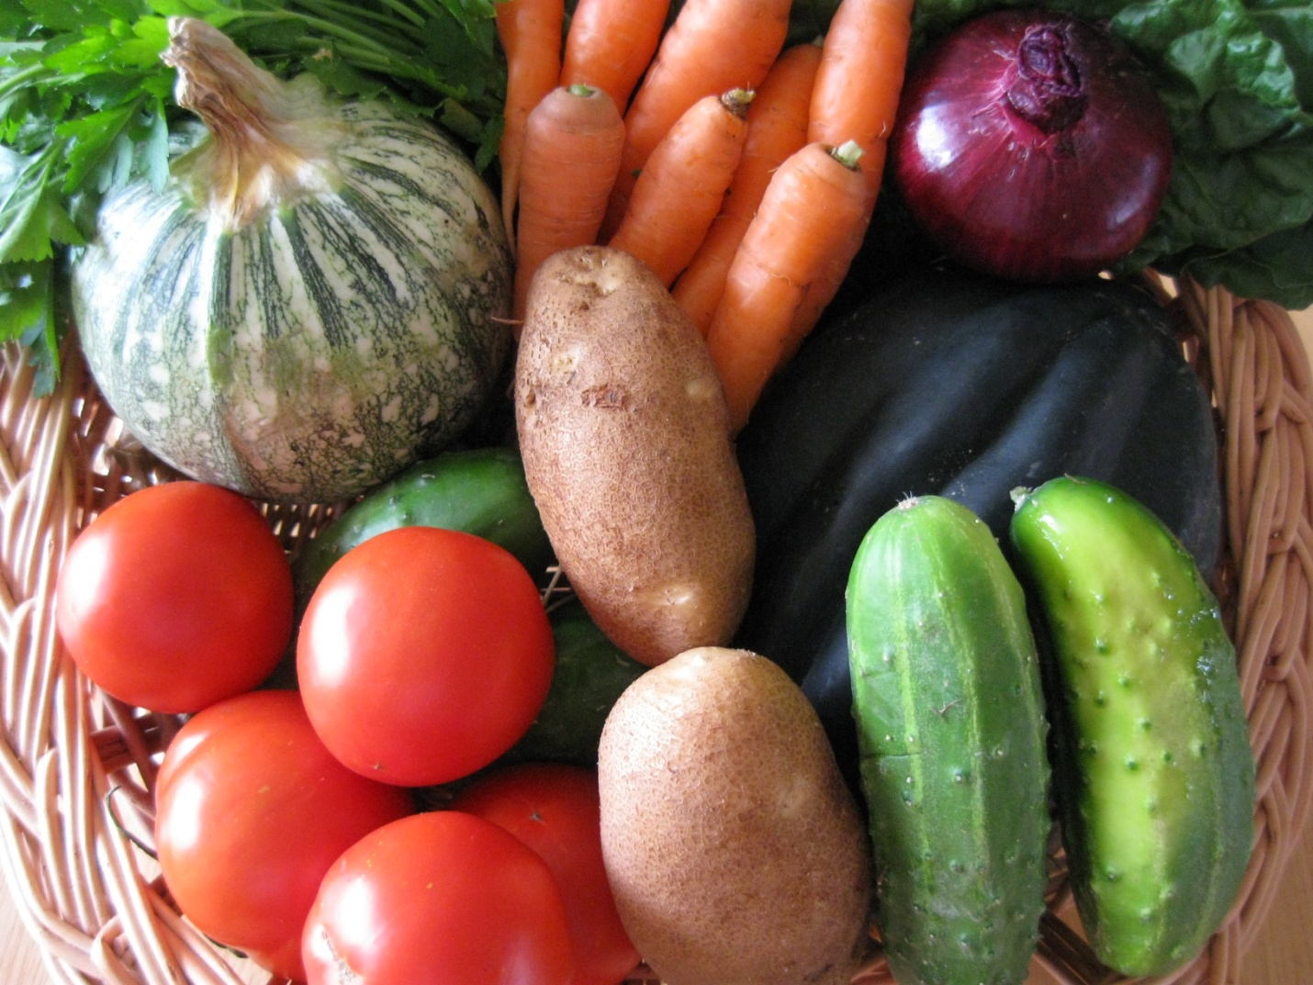

Farm to School thrives on relationships. In order to be successful, each partner must understand the needs and working conditions of the other. Shar­ing the information below with producers can go a long way toward a good working relationship.

**SFAs must inform producers of the following:**

* An understanding of the school nutrition pro­gram—its history, purpose, and how it operates.
* An explanation of the school system’s bidding process.
* How producers will be notified when bids are released.
* An estimate of what items and how much of those items will be needed throughout the school year.
* The total estimated volume of each item to be purchased.
* Delivery schedule needed: date, time of day, frequency, and location.
* Packing requirements: standard box, grade, loose pack, or bulk.
* Post-harvest handling practices: Is the product to be delivered pre-cooled? How clean should the product be? Does the product require processing prior to delivery?
* Payment terms and payment processes.
* Names and phone numbers of the contact people for ordering, billing and trouble shooting.

**Producers must inform the SFA of the following:**

* **Product Information**
  + Which products types and volume are produced?
  + What time of year and how often are products available?
  + How much advance notice can the producer give of available product?
  + What is the price per unit?
* **Food Safety & Liability**
  + What kind of storage is necessary to keep products fresh and in good condition?
  + What food safety plans/procedures does the producer have in place?
  + Does the producer carry liability insurance?
* **Other Considerations**
  + What transportation and delivery options can be arranged?
  + What methods of communication are mutually agreeable?

SFAs can utilize tools like a Producer Survey **Attachment #1** or Producer Checklist **Attachment #2**. These are excellent examples of ways SFAS can collect producer information prior to purchase. The survey is a tool used by The Wisconsin Farm to School, while the check list was compiled by Andrea Rissing, Northern Iowa Food & Farm Partnership Farm to School Coordinator.

**Understanding the Regulations that Guide Purchasing Local Food**

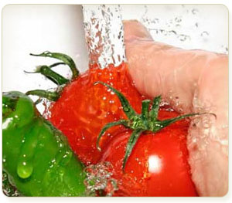

SFAs must engage in conversation with their local (county) health inspector. They can help you understand the regulatory requirements for purchasing farm fresh food and can help you put in place a good system of documentation and traceability for all products purchased from local producers

**Food Safety**

**How can I improve the safety of the food from my farm?**

Over the last few years, many people were sickened and some even died as a result of eating products such as spinach, peanuts, beef, cantaloupes, and eggs that contained harmful bacteria. These outbreaks have caused serious alarm about the way producers grow and handle their food. Institutional markets need to know that the food they buy from producers is not going to sicken their customers, especially schoolchildren. In order to address the concerns of these important buyers, producers should be prepared to show that they grow and handle food in a way that makes it safe for everyone to eat. One way you can increase your chances of selling to institutional markets is to learn about Good Agricultural Practices or GAPs. GAPs are a voluntary set of food-safety guidelines designed to help you handle food safely on your farm and all the way to market. This includes developing a food safety plan, training your employees, and documenting your farm practices to reduce the risk of dangerous bacteria or toxins in your farm products.

Food safety in Wyoming should be a priority for schools and local producers. National and state food safety regulations are applicable at every school. Other regulations and procedures may be dependent on the school and type of product. Below are some important Wyoming resources:

* The Wyoming Department of Agriculture Consumer Health Services oversees food safety in WY: [agriculture.wy.gov/divisions/chs](http://agriculture.wy.gov/divisions/chs)
* This USDA publication gives recommendation for handling fresh produce in schools: [www.fns.usda.gov/fns/safety/pdf/best_practices.pdf](http://www.fns.usda.gov/fns/safety/pdf/best_practices.pdf)
* GAP (Good Agricultural Practices) and GHP (Good Handling Practices) provide principles for safe production and handling processes.
* The USDA Grading, Certification and Verification webpage includes GAP and GHP information: [www.ams.usda.gov/AMSv1.0/ams.fetchTemplateData.do?template=TemplateN&page=GAPGHPAuditVerificationProgram](http://www.ams.usda.gov/AMSv1.0/ams.fetchTemplateData.do?template=TemplateN&page=GAPGHPAuditVerificationProgram)

**Staff Training Resources**

* The USDA webpage addressing food safety aspects (including staff training) in Farm to School programs: [www.fns.usda.gov/cnd/f2s/implementing/safety.htm](http://www.fns.usda.gov/cnd/f2s/implementing/safety.htm%20)
* ServeSafe presents training information and programs for food safety practices: [www.servsafe.com/home](http://www.servsafe.com/home)

*Note: Some producers may be GAP Certified. GAP stands for Good Agricultural Practices and it is a certification program that many farms that sell to larger food distributors participate in.GAP Certification is not a requirement for farms to sell their products to schools. However, if a farm you are purchasing product from is GAP Certified, you probably do not need to go to the additional effort to fill out your own food safety checklist. Many small producers may not be GAP Certified—audits are expensive and there is no federal or state GAP mandate for small producers—but they may have an on‐farm food safety plan that specifies the Good Agricultural Practices they use. You might ask your producers if they have implemented a GAP plan, and if so for a copy of it. If they don’t have a written plan, you may request they develop one, but give them several weeks to complete it.*

If we consider the different categories of food purchased in school food service operations, the basic guidelines for purchasing from local sources are:

**MeatC:\Program Files\Microsoft Office\MEDIA\CAGCAT10\j0149627.wmf**

Red meat animals raised in Wyoming and offered for sale within Wyoming must be slaughtered and processed in a state Department of Agriculture‐inspected facility. If that meat is bought or sold across state lines, it must be processed in a federal USDA‐ inspected facility. Animals slaughtered and processed in a “custom‐exempt” plant may not be sold; that meat is for consumption by the owner(s) of the animal.

**Poultry C:\Users\sbenni\AppData\Local\Microsoft\Windows\Temporary Internet Files\Content.IE5\0ZUQQGDC\MC900331609[1].WMF**

Poultry raised in Wyoming and offered for sale within the state must be slaughtered and processed in a state Department of Agriculture ‐inspected plant, a USDA‐inspected plant, or be a grower inspected by the state. Wyoming agricultural producers selling raw poultry are exempt from licensing but not inspection. However, as with red meat, only poultry processed in a USDA‐inspected plant may be sold or bought across state lines.

**Dairy Products C:\Users\sbenni\AppData\Local\Microsoft\Windows\Temporary Internet Files\Content.IE5\0ZUQQGDC\MC900239171[1].WMF**

Dairy products used in school food service programs must be pasteurized.

**Eggs C:\Users\sbenni\AppData\Local\Microsoft\Windows\Temporary Internet Files\Content.IE5\Q0QGQ7ES\MC900215943[1].WMF**

Grade B or better eggs are required to be used in food service establishments, including school food service programs. Fresh shell eggs (Grade B or better) may be purchased from local producers if the farmer holds an egg‐grader license from the Wyoming Department of Agriculture.

For additional reference, please see chapter 15 of the Wyoming Food Safety Rule for all of the requirements for selling and grading eggs

**Produce (Fruit and Vegetables)** C:\Users\sbenni\AppData\Local\Microsoft\Windows\Temporary Internet Files\Content.IE5\KH6T3B72\MC900413494[1].WMF

No formal inspections or regulatory oversight are required of fresh, whole uncut, raw produce. Processed items (including minimally processed such as sliced, chopped, or peeled) must have been processed by a Wyoming licensed manufacturer in a licensed and inspected facility. Processors/manufacturers must be licensed by the Wyoming Department of Agriculture Consumer Health Services division. Additionally, if the processor/manufacturer is from another state they must have a Wyoming Food license as a distributor.

References are from the Wyoming Food Safety Rule 2012

[www.wyagric.state.wy.us/divisions/chs/food-safety](http://www.wyagric.state.wy.us/divisions/chs/food-safety)

**Three Easy Steps for an SFA to Ensuring Food Safety When Purchasing Farm Fresh Food**

Including farm fresh products in your school food service programs is a wonderful way to connect children with healthy foods and raise their awareness of where their food comes from. Yet, if you haven’t purchased directly from local farms in the past, you may be unsure about how to do recordkeeping to track food safety practices from the farm to your cafeteria.

1. Record keeping is important for tracing a product back to its source should a food safety problem arise. Make sure you keep records from the vendors on the products so you can identify the source of the product (often called traceability). Use the vendor’s invoice or receipt similar to the one below.

**The following may be utilized as a receipt from the producer:**

Date: ________________

Received by:_______________________

Donated: _________ Purchased:_________ Purchase price:_______

Description and volume of product purchased: _________________

_______________________________________________________

Date harvested: __________________________________________

Harvest location: ___________________Lot # if available: _________________

Name of grower: _________________________________________

Address: ________________________________________________

Phone: __________________ Email:__________________________

1. Utilize the information and resources in this guide to help you procure local foods.
2. Consult with your local health inspector or sanitarian, as they can provide assistance if needed to ensure food safety from the farm to the plate.

**Liability Insurance Requirements**

Many schools and/or distributors require a specific level of product liability insurance. There are currently no federal guidelines on the amount of insurance required, but it typically averages $1 to 5 million. This means that if someone gets sick, the insurance company will cover the medical or legal expenses of the injury up to $1 million or $5 million dollars in damage. This type of insurance could cost producers anywhere from $500 to $1,500 a year, depending on the farm income and what kind of coverage they want.

SFAs need to check with their Business Managers to determine what type of coverage and how much coverage they may need.

**What is product liability insurance?**

Insurance is a tool producers can purchase to protect their family or their farm from financial risk. There are many different types of insurance. If a producer sells fresh fruits, vegetables, or other farm products such as meat, cheese, or value-added goods, they should carry a type of insurance called product liability insurance. Product liability insurance protects producers against people who may claim to suffer illness, injury, or loss due to the product the producer sold them. This kind of insurance protects the producer from being sued if someone says they became ill from consuming their products. Product liability insurance covers medical expenses, legal expenses, and more.

**Procurement**

**Additional Procurement Considerations**

It is important to be aware of the required procurement regulations. Public agencies (which include School Districts) must use the most restrictive of State, local, or Federal standards. Private schools typically utilize the Federal policy or have one written specific to their school.

**Small Purchases must be less than:**

* + - * Federal $150,000.00
      * State $7,500.00, Elected Officials $20,000.00
      * School Districts $25,000.00 (W.S. 21-3-110 (B)(viii)
        + **SFAs must get competitive bids for purchases between $10,000.00 and $25,000.00**
      * Local (Depends on the SFAs written procurement standards)

**For School Districts the general rules are:**

* For purchases less than $10,000: No bidding process is required but follow prudent purchasing practices.
* For purchases between $10,000 ‐ $25,000 again, no formal bidding process is required but the District must receive competitive bids.
* For purchases greater than $25,000: A formal bid or proposal is required.

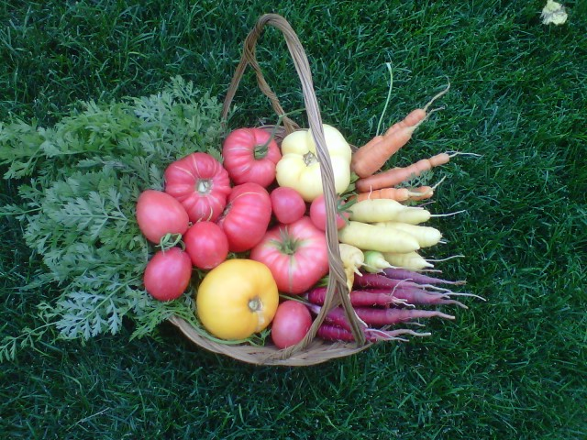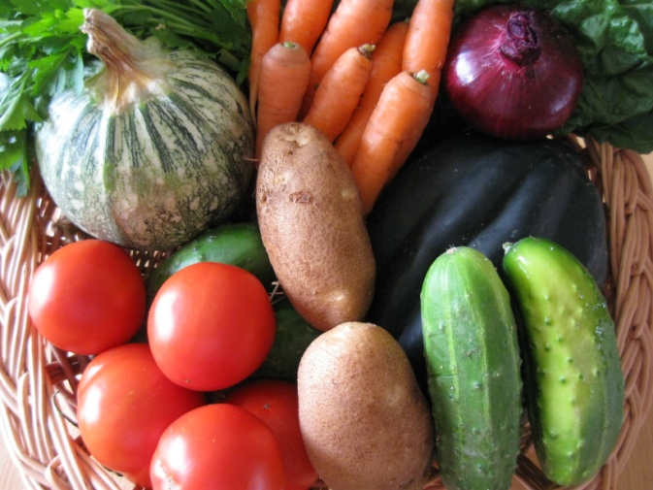

**The purpose of Procurement requirements:**

* Enhance competition to get the best value
* Fair process- level playing field
* Safeguard against favoritism

**What is “Open and Free Competition?”**

The underlying foundation of all procurement, without regard to dollar value, is the procurement must be conducted in a manner that provides maximum open and free competition. Free and open competition basically means that all suppliers are “playing on a level playing field” with the same opportunity to compete. Procurement procedures must not restrict or eliminate competition.

**Procurement Options**

**Procurement Steps**

**Step 1.** SFAs determine their small purchase threshold level. This may be the state public school district level of $25,000 or, if applicable, a more restrictive amount set by the district. Remember to use the most restrictive level.

**Step 2.** Determine the estimated purchase amount of the product.

**Step 3.** Compare the estimated purchase amount to the purchasing threshold to determine if the **for­mal** or **informal** procurement method will be used.

**Example:** Produce is bid on a weekly basis. Produce purchases are usually around $550 and are not expected to exceed $750. The local dis­trict small purchases threshold is $25,000. Because the total purchases will fall below the $25,000 limit, an informal procurement method can be used.

**Informal Procurement Method**

If the purchases fall below $25,000 (or the district’s small purchase threshold if it’s more restrictive), the SFA must approach 3 vendors and obtain price quotes. SFAs may not intentionally split purchases to fall below the small purchase threshold and avoid formal procurement meth­ods. Follow the steps below.

**Informal Procurement:**

1. Develop your specs in writing
2. Identify sources eligible, able and willing to provide products
3. Contact at least three sources
4. Evaluate bidders’ response to your specs
5. Determine most responsive bidder at lowest price

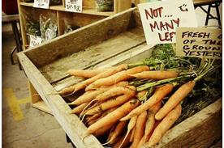

**Formal Procurement Method**

If the procurement exceeds the small purchase thresh­old ($25,000, unless the district has a more restrictive amount), a formal procurement method is required. This entails public notification of the solicitation and a sealed bidding process. When procuring locally grown food, the notification may focus on the area in which the school is situated as a criteria of the solicitation. In a situation where the solicitation for locally unprocessed agricultural products is open to offers beyond the local area, geographic preference points can be granted to lo­cal producers who respond to the solicitation.

**Competitive Sealed Bids –** A method of procure­ment whereby sealed bids are publicly solicited and a fixed-price contract is awarded to the responsible bidder whose bid, conforming with all the material terms and conditions of the invitation for bid, is lowest in price.

**Competitive Proposals –** A method of procurement whereby proposals are requested from a number of sourc­es and the request for proposal is publicized, negotiations are conducted with more than one of the sources submit­ting offers, and either a fixed-price or cost-reimbursable type contract is awarded, as appropriate. Competitive negotiation may be used if conditions are not appropriate for the use of competitive sealed bids.

**Formal Procurement:**

1. Develop solicitation and incorporate geographical preference points into scoring criteria
2. Publicly announce the IFB/RFP
3. Evaluate bidders using established criteria
4. Producers of locally-grown unprocessed products receive extra points in scoring
5. Determine most responsive and responsible bidder at lowest price

Developing Product Specifications

**The key to successful purchasing of local food items is to take some steps before beginning the pro­curement process. Evaluating current food service operations and needs is very important.**

Developing specifications that of the products the SFA seeks sets the stage for clear communication and a successful exchange. The following examples are indicators that may be used for a product’s specification. Although not all-encompass­ing, the examples provide some specification elements that are important factors to discuss with local pro­ducers to ensure that expectations and requirements are clear.

**Specification elements & examples:**

* **Size:** For example,indicate the size an apple must be to qualify as part of a reimbursable meal, so that expectations are set up front.
* **Quantity:** Producers and SFAs sometimes speak differ­ent languages—schools may not be used to ordering apples in “bushels;” be aware of language barriers.
* **Quality:** For example, indicate that lettuce must be a healthy green color with no brown leaves.
* **Cleanliness:** Indicate that lettuce should be clean with no visible signs of dirt or insects.
* **Packaging:** A local producer may sell product in 25 pound boxes, but the SFA may need lighter/smaller packaging in order for staff to carry. What type of packaging can you expect, standard box, grade, loose pack, bulk, etc? Note that package must protect integrity of food items.
* **Food Safety:** Include a checklist of questions for the producer to complete regarding their agricultural practices.
* **Delivery:** Establish a delivery day and time for products. How many deliveries are made per week per loca­tion and at what times? What type of delivery vehicle does the producer have? Is it climate controlled?
* **Other:** 
  + How far in advance will producer be able to inform you of available product?
  + What is the communication process if producer is unable to complete order (amount or quality) and what is the timeframe for this notice?
  + What is the price per unit?
  + What substitutes are acceptable, if any?

Consult USDA resources such as the *Food Buying Guide for Child Nutrition Programs* and *Fruits and Vegetables Galore* to aid in the development of product specifications. Also, visit with other SFAs about their product specifications.

**Specifications that are not product specific are:**

* **Length of bid, transaction:** Bid period. 30 days, Monthly, Season
* **Order frequency:** Monthly, weekly, specific day of the week, one time order?
* **Frequency of delivery:** Weekly, bi-weekly, monthly.
* **Cost**
* **Payment frequency, payment procedures:** What is the lead time required by school district accounting office to add vendors? What is the timing for the payment of invoices?
* **Number of sites deliveries will be made to** (include locations and addresses). Also indicate where the delivery is to be made, e.g. to loading dock, into the milk cooler, or inside kitchen door.
* **How orders will be transmitted:** How do you prefer to place orders? Phone, fax, e-mail?
* **Insurance and/or liability policy requirements.**

**Most of the items reference above can be part of a producer survey and/or checklist.**

Below are several sample tools for a successful Farm to School Purchase:

* Sample Vendor Letter
* Sample Specification Worksheet
* Product Availability and Pricing Sheet
* Sample Simple Bid Sheet with Scoring
* Sample New Producer Meeting Checklist
* Attachment #1
* Attachment #2

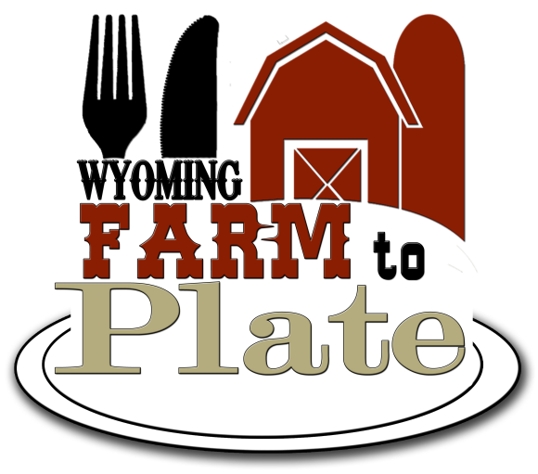

*Sample Vendor Letter*

*Send with: 1) producer Survey/Checklist and/or 2) availability/price form or with any needed District information*

Date

Dear Producer:

Wyoming School District #1 is now accepting price quotes for fruits and vegetables for delivery to the district food service for the 2013/2014 school year.

Wyoming School District #1 is tryingto identify producers that may have the ability to supply produce for the school cafeteria meals as part of the district’s new Farm to School Program.

Enclosed please find a Producer Survey/Checklist for you to submit to the Food Service Departmentshould you wish to submit one. Please submit this information to the address below by ***noon on August 22, 2013*** to the attention of the Food Service Director.

If you are selected as a potential producer for our Farm to School Program you will be contacted for purchasing information and/or asked to submit quotes (bids). A meeting may also be schedule with the Food Service Director and/or other district administration. All arrangements between Wyoming School District #1 and selected producers regarding delivery schedules, ordering, payment and availability/seasonality of produce will be made during the above-mentioned meeting. A contract may be awarded, additionally, Wyoming School District #1 reserves the right to award contracts (bids) to multiple producers.

Please direct all responses, questions, and inquiries to:

Food Service Department

School District

Address

City, State, Zip

Phone

E-mail:

Sincerely,

Specification Worksheet

|  |  |
| --- | --- |
| Item Name: |  |
| Description (variety): |  |
| Size: |  |
| Grade/Standard: |  |
| Pack Size/Weight: |  |
| Price Quote:  (by lb., dozen, case) |  |
| Ripeness: (Maximum/Minimal level of ripeness acceptable) |  |
| Delivery/Frequency: |  |
| Growing Preference: |  |
| Other: |  |

Sample Specification Worksheet for Apples

|  |  |
| --- | --- |
| Item Name: | **Apples** |
| Description (variety): | **Gala, apples to be fresh-picked, no bruising, no worm or insect damage, packed in a clean, unused box.** |
| Size: | **2 7/8 to 2 ¾ diameter** |
| Grade/Standard: | **US utility** |
| Pack Size/Weight: | **125-138 count** |
| Price Quote:  (by lb., dozen, case) | **Standard 40lb box** |
| Ripeness: (Maximum/Minimal level of ripeness acceptable) | **Fully tree ripened** |
| Delivery/Frequency: | **Every three weeks and to be delivered to 2 sites.**  **Or**  **Purchased at local farmer’s market** |
| Growing Preference: | **Grown within 75 miles radius**  **Or**  **Grown within ABC County** |
| Other: | **Un-waxed (not washed; washing would remove the natural wax)** |

Product Availability and Pricing

Farm/Business Name:

Contact name:

Address:

Phone: Fax:

Place order via (phone/fax/email/at Market):

Place an order by (date/day of week):

|  |
| --- |
| Item Pack Price Comments |
|  |
|  |
|  |
|  |
|  |
|  |
|  |
|  |
|  |
|  |
|  |
|  |
|  |
|  |

Sample Product Availability and Pricing

Farm/Business Name: **ABC Farm**

Contact name: **Susan Benning**

Address: **123 Sesame Street**

Phone: **777-6280**  Fax:

Place order via (phone/fax/email/at Market): **Market**

Place an order by (date/day of week): **Monday, June 3rd**

|  |
| --- |
| Item Pack Price Comments |
| **Spinach 10 lbs. $ 4.00/ lb leaf cut, washed** |
| **Apples 120-135 ct $28/Case mixed, unwashed** |
| **Lettuce-Romaine 12 ct $10/Case whole, washed** |
|  |
|  |
|  |
|  |
|  |
|  |
|  |
|  |
|  |
|  |
|  |

Sample Simple Bid Sheet with Scoring

**Wyoming School District is accepting bids for apples**

The minimum specifications are:

**Apples, Mixed varieties (Gala, Red Delicious, Fireside, Jonathan, Empire, Cortland, Ida**

**Red), Fresh 125-138 Count, Whole**

Items submitted for bid must be delivered to the school food service. Please note the following: price per case, available varieties, location of orchard and availability to either visit a school for educational activities or host a school field trip on your orchard.

**Grower A**

Apples, Fireside, Jonathon, Empire, Cortland, Fresh 125-138 count, Whole: $26.00 per case.

Located 10 miles from District Office, in County. Able to host field trip. Available for pick up on Wednesdays, no delivery.

**Grower B**

Apples, Red Delicious, Jonathon, Fireside, Cortland, Ida Red, Fresh 125-138 count, Whole: $30.00 per case. Located 25 miles from District Office, in County. Delivery to school food service. Available for a school visit and able to host field trip.

**Grower C**

Apples,Red Delicious, Gala, Fresh 125-135 count, Whole: $28.00 per case. Located in Colorado. Delivery to food service.

Weight Criteria

15 points Delivery

50 points Cost

15 points Count/size

10 points Located within County

5 points More than two varieties provided

5 points Available to visit District or host a field trip

Total: 100 points

|  |  |  |  |
| --- | --- | --- | --- |
|  | Grower A | Grower B | Grower C |
| Delivery | 0 | 15 | 15 |
| Cost | 50 | 40 | 45 |
| Count | 15 | 15 | 12 |
| Location | 10 | 10 | 0 |
| # of varieties | 5 | 5 | 0 |
| Visit District or field trip | 3 | 5 | 0 |
| TOTAL POINTS | 83 | 90 | 72 |

Bid to be awarded to Grower B

Sample Simple Beef Bid Sheet with Scoring

**Wyoming School District is accepting bids for beef**

The minimum specifications are:

**Raw beef, no mechanical separation, minimally processed, no additives or preservatives, with minimum fat of 80/20. Bid is for Ground Beef 5lb. packs, 40lb case. Beef Patties 4:1, 60 each; 15 lb. case. Estimated usage 5,000 lbs.**

**Delivery for 2013-2014 school year expected by August 20, 2013 for Wyoming School District. Bid responses must include raw food cost (price), delivery cost, and pack sizes.**

**Producer A**

**Producer B**

**Producer C**

Weight Criteria

5 points Pack Size

10 points Total Pounds

50 points Price

15 points Delivery Cost

10 points Located within County

5 points Can Provide both Products

5 points Total Pounds

Total: 100 points

|  |  |  |  |
| --- | --- | --- | --- |
|  | Grower A | Grower B | Grower C |
| Pack Size |  |  |  |
| Total Pounds |  |  |  |
| Price |  |  |  |
| Delivery Cost |  |  |  |
| Location |  |  |  |
| Both Products |  |  |  |
| Total Pounds |  |  |  |
| TOTAL POINTS |  |  |  |

Sample New Producer Meeting Checklist

**BEFORE**

* Provide the Producer with the Producer Survey/Checklist and either provide to new vendor prior to the meeting or have them bring to the meeting.

**DURING**

* Review/complete the survey/checklist together
* Discuss and negotiate the important details
* Estimated volume of product to be delivered
* Ordering process (including best way to contact one another)
* Delivery schedule including time of day, frequency, location
* Packing requirements: Standard box, grade, loose pack, bulk, etc.
* Post-harvest handling practices: Is the produce pre-cooled? How clean should the product be?
* Cost per unit, payment terms, payment process
* Names, phone numbers and emails of contact people for ordering and billing
* If they are willing and able, invite them to participate in a tasting event or attend lunch on a day when their product is being served

**AFTER**

* Follow up with new producers
* Provide feedback on their product and service—both positive and negative
* Directly address any issues regarding product or service
* Consider exploring ways to work together to promote new foods to students