Verification Instructions

NOTE - If you are a provision school, private school or RCCI, call Tamra Jackson at 777-6263.

In August schools and agencies are sent which type of verification you will do for the current year. This determination is based on your non-response rate last year. If you do not have this information, call Tamra Jackson at 777-6263.

Log onto the CNP on line site and click on Applications:
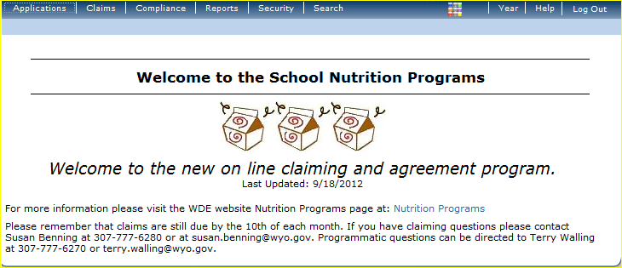

Open the Verification Report Item:
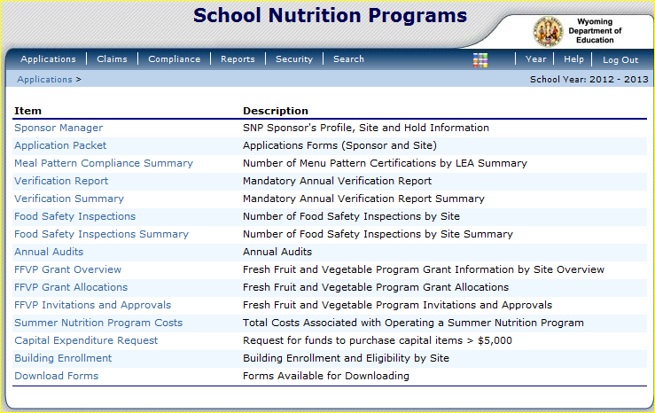
Choose school year 2012-2013
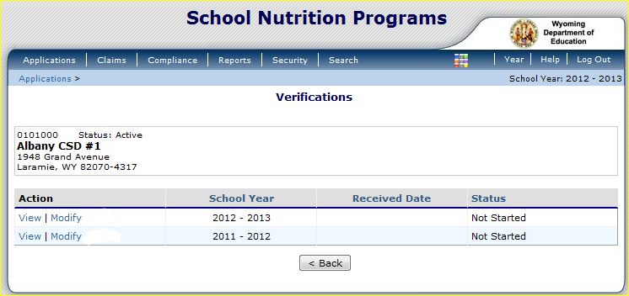

Complete the Verification Contact Information. (1-4)
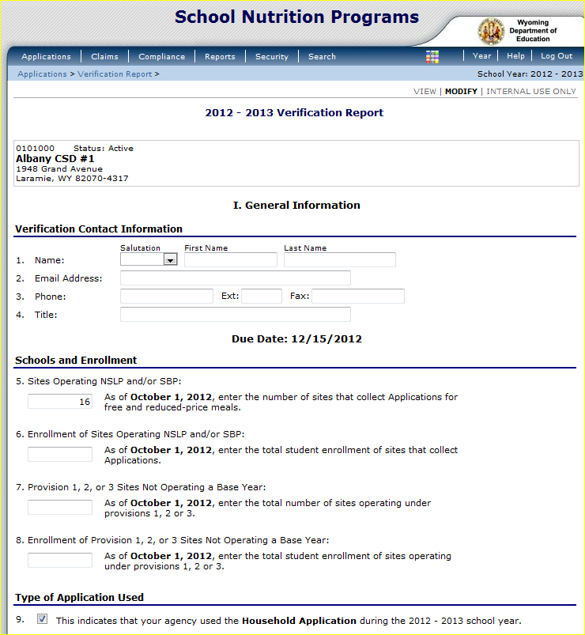
Number 9 is self populated.

7 & 8 are for provision sites only.
Complete Number 6.

Number 5 is self populated.

Complete 10 – 19. This form is the same as the hard copy form you used previously.
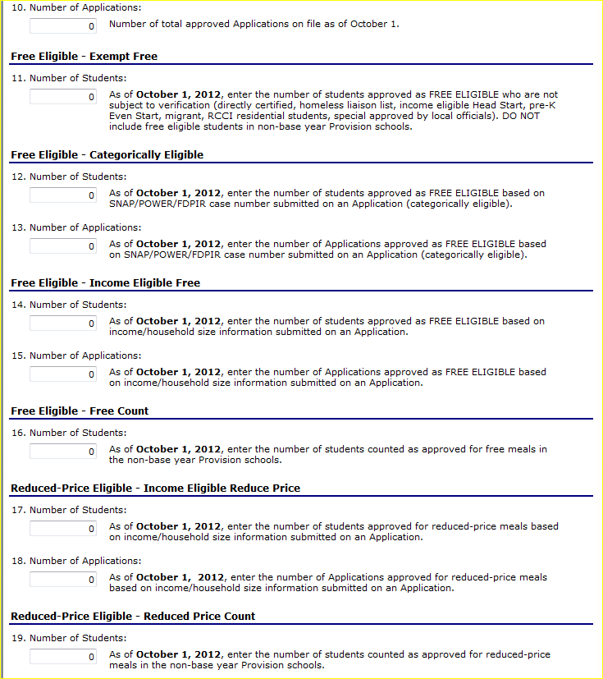

After you determine how many verifications to send to households, complete the “We Must Check Your Application” letter found in the Application Packet which can be found at: http://edu.wyoming.gov/Programs/nutrition/national_school_lunch_program.aspx
Under Local Education Agency Forms.
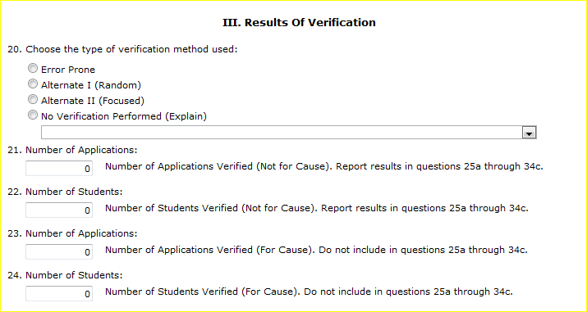

After you receive the requested information from the household you must now determine if there is a change in benefits and complete lines 25-35.
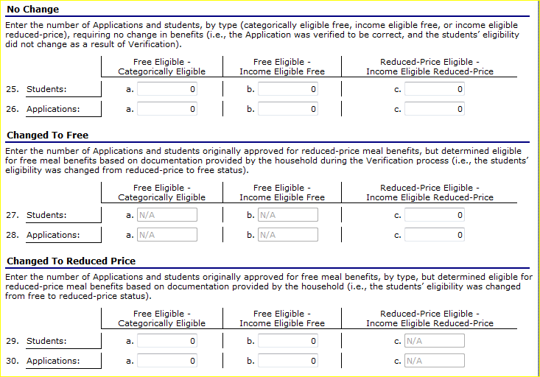

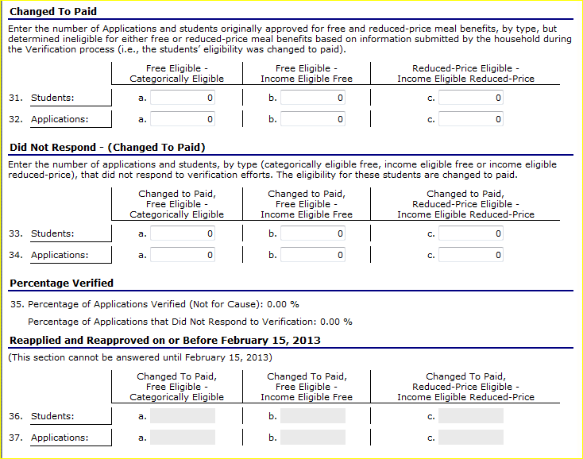
On February 15, complete lines 36 & 37.
When you are done completing all of the steps, click save, then e-mail Tamra Jackson to inform her of your completion so she can approve or deny it.
