Wyoming Department
Of Education
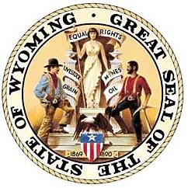
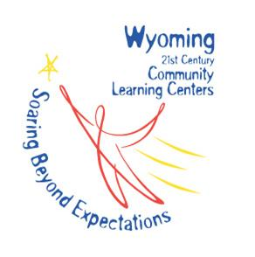

NOTICE OF INTENT TO APPLY
for
2014-2019 (10th Cohort)
21ST CENTURY COMMUNITY LEARNING CENTERS GRANT

Submit this form no later than July 29, 2014 to assist the Wyoming Department of Education in making the necessary preparations for the 21st Century Community Learning Centers grant competition. Potential applicants will be notified if they include a school that is already participating in a 21st CCLC grant or if more than one potential applicant has listed the school to be served in a new grant. Every effort should be made by potential applicants and current subgrantees to define a unique population to target and serve in order to prevent data reporting difficulties and duplication.
Please note: Cohort 9 Subgrantees awarded in May 2014 are not eligible to apply for Cohort 10.

Applicant Name :_______________________________________________________

Contact Person(s): _____________________________________________________

Title: _________________________________________________________________

Phone: __________________ E-mail: ___________________________________

Fiscal Agent (leave blank if the applicant will act as fiscal agent)_______________________________

___________________________________________________________________________________

Have you ever received a 21st CCLC award as an applicant?_____________________

Have you ever received 21st CCLC funding through a contract?___________________

Please list the cohorts and/or years: ________________________________________

- Names of Schools to be served, % of school population to be served, and contact person at the school who will verify support:

- Please list the names of organizations that will provide 21stCCLC programming to students, if other than organization submitting the grant. Indicate whether they are a partner/co-applicant or a subcontractor.

- Projected Funding Request: $________________ (Please note: Grant requests must be between $50,000-$200,000 and reflect reasonable and necessary costs relative to the number of students served.)

Submission of this form is not a prerequisite for application of grant funds, nor does it obligate the organization to submit an application.

Please mail, email or fax this form to: Karen Bierhaus, karen.bierhaus@wyo.gov
Wyoming Department of Education
Attn: Karen Bierhaus
320 West Main St.
Riverton, WY 82501
FAX 307.777.9257

