K-12 WY Social Studies Teachers’ Summit

May 9-10, 2014 - Casper, Wyoming



Office of the Superintendent of Public Instruction

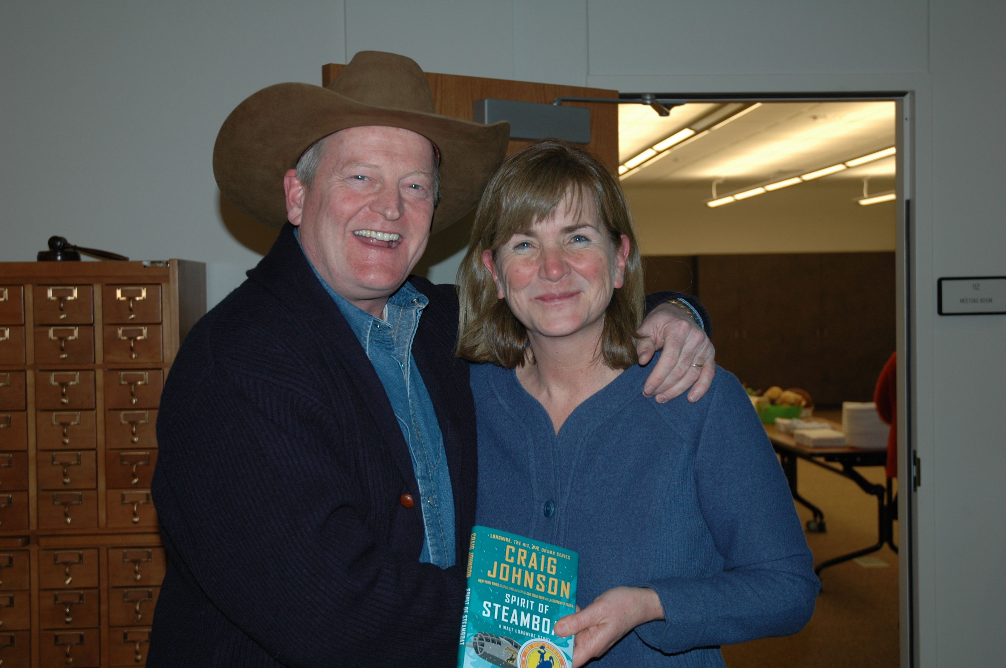

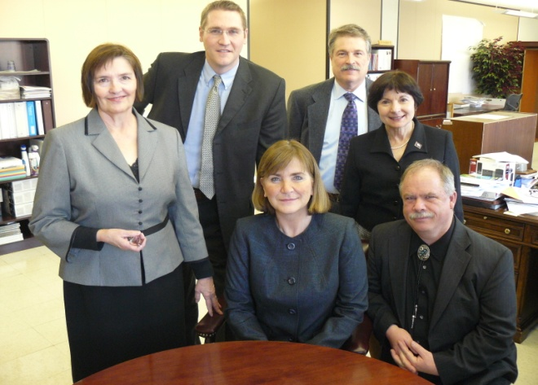



Cindy at the book signing of Wyoming author Craig Johnson.

**May, 2015**

**Dear Attendees of the Social Studies Teachers’ Summit,**

**My mom was a first grade teacher when I started school, and, of course, I admired her! I wanted to be an educator too. All my life I have held teachers in the highest esteem.**

**So, it is with a great sense of pride that I welcome you to this conference and wish you a wonderful time learning, sharing and working together. Your service to our kids is of paramount importance as we daily recreate how to live together in a civil society. You are a precious Wyoming resource serving a high calling.**

**Sincerely,**

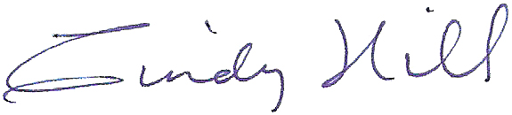

**Cindy Hill, Superintendent of Public Instruction**

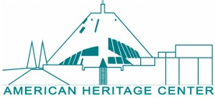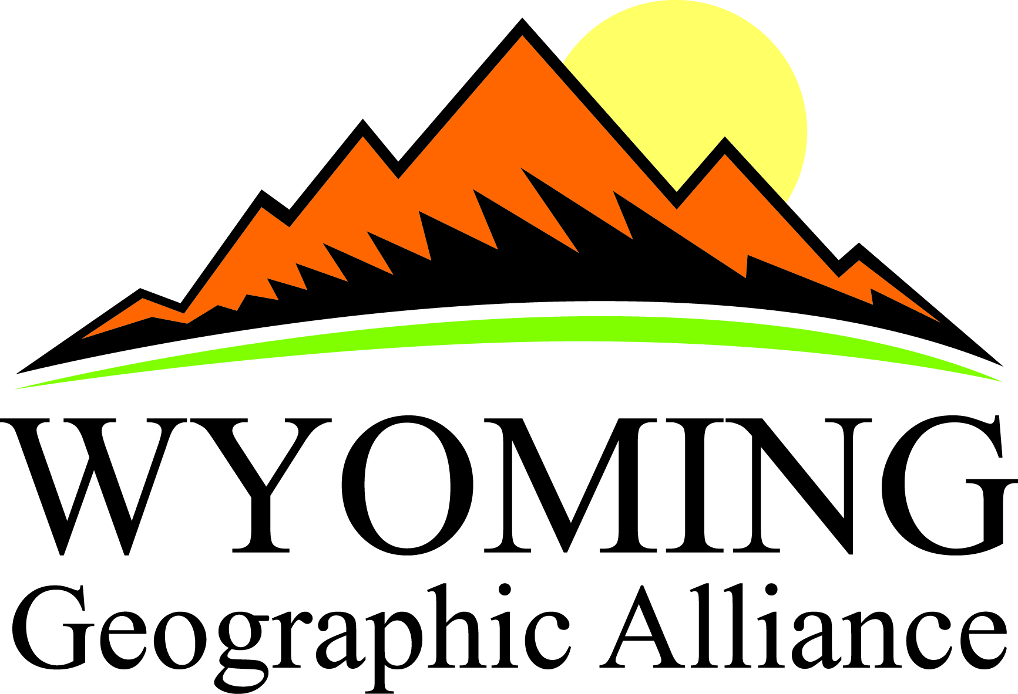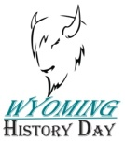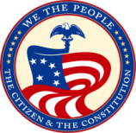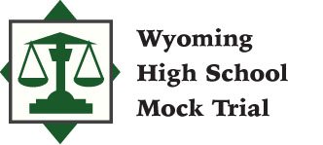

**Friday, May 9 - Hilton Garden Inn Grand Ballroom**

**6:00 - 7:00 PM**

**Registration, Hors d’oeuvres, and View of Exhibitor Materials**

**7:00 - 7:15 PM**

**Maria Gallo - School Violence Prevention Demonstration Program and the Native American Initiative**

Maria Gallo, curriculum consultant with the Center for Civic Education, will speak about the School Violence Prevention Demonstration Program and how this program resulted in the Native American Initiative.

**7:15 - 7:30 PM**

**Echo Klaproth, Wyoming Poet Laureate - *Power of Place***

Lectio Divina is a divine calling to poetry and the power of place. Like a spiritual encounter, studying the power of place is the savoring and saving of a culture’s history. Poetry can help the reader or listener appreciate the moments by focusing on feelings and impressions, by seeing into the energy of life.

Edwin Muir said, “Time wakens a longing more poignant than all the longings caused by the division of lovers in space, for there is no road back into its country. Our bodies were not made for that journey; only the imagination can venture upon it; and the setting out, the road, and the arrival: all is imagination. Our memories of a place, no matter how fond we were of it, are little more than a confusion of lights on a ground of darkness.”

**7:30 - 8:00 PM**

**Registration, Hors d’oeuvres, View Exhibitors’ Materials**

**Sharing and Collaborating**

**Saturday, May 10 - Kelly Walsh High School**

**7:30 - 8:00 AM**

**Registration - *Auditorium Foyer***

**8:00 - 8:10 AM**

**Welcome - Superintendent Cindy Hill - *Auditorium***

**8:10 - 8:50 AM**

**James Loewen - “Lies My Teachers Told Me and How to Avoid Them” - *Auditorium***

American history is full of fantastic and important stories. These stories have the power to spellbind audiences, even audiences of difficult seventh graders. Yet they sleep through the classes that present it.

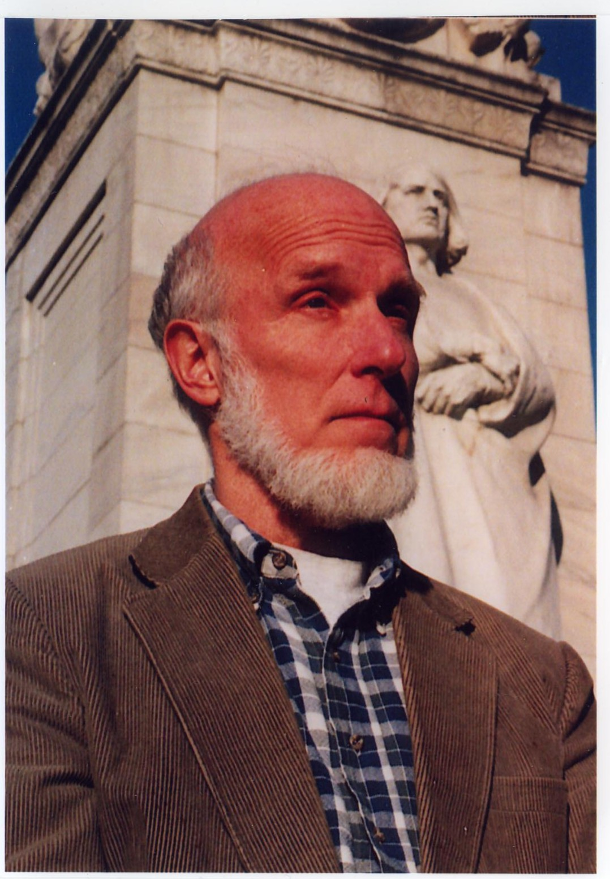

What has gone wrong?

We begin to get a handle on that question by noting that textbooks dominate history teaching more than any other field. Students are right: the books are boring. The stories they tell are predictable because every problem is getting solved, if it has not been already. Textbooks exclude conflict or real suspense. They leave out anything that might reflect badly upon our national character. No wonder students lose interest. We have got to do better.

**8:55 - 9:45 AM**

**Technology Strand - *Library***

**Joseph Kerski - Mapping the Social Studies**

Join geographer Joseph Kerski as we explore topics in history, geography, civics, and economics, examining historical elections, weather extremes, land use and population change, a proposed road through the Serengeti, median age and income, and more.  We will dig into dynamic web-mapping tools.

**Elementary Social Studies Strand A - *Room 142***

**Maria Gallo - The Fair Bears Help Us Understand the Issue of Corrective Justice**

Through story book characters and examples from everyday life, students are able to understand and apply basic principles and considerations useful in examining issues of justice. This session will focus on corrective justice. The Fair Bears will help students learn fair ways to respond to a wrong someone has done or an injury they have caused.

**Elementary Social Studies Strand B - *Room 136***

**Patsy Parkin - Wyoming History for Elementary Students**

“Wyoming: Crossroads of a Continent”is a history textbook targeted especially to the reading and instructional level of fourth graders. The book covers topics from dinosaur times to statehood and contains many famous historical paintings and photographs, lists of fiction and nonfiction books for young readers, and ideas for internet resources. Also available is a 144-page teacher guide that contains study guides, activities, and possible evaluations for each chapter, as well as an entire section on map skills. This session will share amazing Wyoming facts and ideas for instruction.

**Secondary Social Studies Strand A - *Room 147***

**James Loewen -** **How to Get Students Doing History**

Middle and high school students need not be restricted to reading history. They can also do history. All history is local. It happened “here.” The women’s movement happened in Sheridan in the First Presbyterian Church, among other places. The Korean War was “forgotten” in Douglas, and remembered too, by a family whose young adult male was killed or forever changed by it. Rock Springs became a sundown town, and Powell even posted a sign. Students can do important research on these and many other topics, including their own families, and doing a great job on these projects can change their lives.

**Secondary Social Studies Strand B *- Room 141***

**Erin O’Donnell - Teaching about the Federal Reserve to Meet Economic Standard**

This workshop from the Federal Reserve will introduce and demonstrate the variety of free resources available to secondary educators in teaching economics and personal finance. Classroom- ready resources will be given to attendees.

**Student Program Strand - *Room 144***

**Richard Kean, Mary Jo Birt and Wyoming History Day Student Team Wheatland Middle – To Hold a More Brilliant Touch: How to Integrate History Day into Your Curriculum**

Richard Kean, WHD State Coordinator, and Mary Jo Birt, Wheatland Middle School teacher, will explain the National History Day Program and provide information about how to participate in the Wyoming History Day experience. The 2014 WHD first place winning Junior Division Group Performance students will perform their ten-minute play and answer questions about their research and development of this project.

**9:50 - 10:05 AM**

**Break - *Library* Refreshments, Wyoming Student Atlas, Visit Exhibitors**

**10:10 - 11:00 AM**

**Technology Strand - *Library***

**Joseph Kerski - From Smartphones to Webmaps: Bringing Citizen Science to Social Studies in Middle and High Schools**

Today’s web-mapping tools allow you and your students to easily gather, map and analyze field data on everything from litter to invasive weeds to historical homes and more. Join geographer Joseph Kerski as we do hands-on exploration of these tools that bridge STEM, social studies, and outdoor education in an inquiry-driven environment.

**Elementary Social Studies Strand A - *Room 142***

**Germaine Wagner - Get Your Groove On! Using Movement to Teach Geography, Discover Place and Solve Wyoming Riddles; Stephanie Brady and Catherine Reeves (WDE) on Informational Reading**

This presentation involves three active lessons focusing on Wyoming Social Studies Standard 5 (People, Places and the Environment) –specifically the theme of “place.” The concepts discussed can be adapted to other topics and grade levels.

**A-Z Place Description:** Students will describe the community where they live using physical and human characteristics. People’s image of a place is based on their experiences, both intellectual and emotional. People’s descriptions of a place reveal their values, attitudes, and perceptions.

**Get Your Groove On:** Kinesthetic learners respond and learn best with movement. Learners will become familiar with the states and capitals that border Wyoming with movement integrated.

**Wyoming Riddles:** Using your Wyoming foldable map, test your knowledge of Wyoming town names with riddles. Read the key on your map and find the grid coordinates on your map.

**Reading Informational Text Closely:** Using their thinking strategies, how do you get students to pay attention to text and text features to wring every bit of meaning out of text possible?

**Elementary Social Studies Strand B - *Room 136***

**Erin O’Donnell - Teaching Economics and Personal Finance in Elementary**

This workshop from the Federal Reserve will introduce the variety of free resources available to elementary educators in teaching economics and personal finance. Classroom-ready resources will be given to attendees.

**Secondary Social Studies Strand A - *Room 147***

**Jessica Flock - The World, Wyoming and Wolves: Visual Literacy, Multiple Perspectives and Primary Sources from the Library of Congress, Secondary Edition!**

Wyoming identity on individual, community and state levels provides a relevant and unique lens for secondary students to evaluate primary-source documents. Selected resources connected to the identity of Wyoming, flora and fauna, local geography and world geography will be highlighted. Learn how to enrich your curriculum with free online digitized primary sources from the Library of Congress, including motion pictures, photographs, WPA posters and songs from the National Jukebox. Strategies for sixth through twelfth grade classrooms will focus on active student engagement, vocabulary development and reading comprehension.

**Secondary Social Studies Strand B - *Room 141***

**Mary Jo Birt - Resourcefully Wyoming: Mapping WY Energy and Agricultural Resources on the Giant Wyoming Map**

Come on in, take off your shoes and sock-hop into Wyoming! These geography lessons are designed to get students out of their seats to activate and energize their learning. Participants will look at a lesson that highlights WY energy: introducing vocabulary, history, geography, and WY agriculture using current state data and ‘your math-brain’ to map out each county’s agricultural resources.

**Student Program Strand - *Room 144***

**Marguerite Herman and Colleen Burridge - Wyoming High School Mock Trial - Casper’s Star Lane Learning Center Mock Trial Team**

Students from Star Lane Center will perform selected aspects of a high school mock trial, using the case from the Wyoming tournament last November, the murder trial of State of Wyoming vs. Cameron Paul. Students will present opening statements, witness examination and closing arguments, showing their mastery of the facts and witness affidavits, their use of the rules of evidence and courtroom decorum, and strategies to convince a jury that Mr. Paul is guilty or innocent.

**11:05 - 11:55 AM**

**Technology Strand - *Library***

**Joseph Kerski - Mapping and Examining the History and Geography of Wyoming**

Make Wyoming’s fascinating and diverse history and geography come alive by the use of inquiry with web-mapping tools, including ArcGIS Online, with geographer Joseph Kerski. Embed audio, video, and photographs into web maps you and your students can create, customize, and share on topics and scales from local city to county to state.

**Special Interest Session for Pre-K through Grade 2 - Auditorium**

**Kelley Norman - Hey, Pre-K through Grade 2 Teachers! Integrating Social Studies into Your Children’s Day Is Fun Stuff**

Kelley will share with you some awesome lessons for the littlest guys and gals you teach integrating social studies themes with read-alouds, interactive writing, independent reading and writing. Lots of ideas to share.

**Elementary Social Studies Strand A - *Room 142***

**Maria Gallo –How Should We Choose People for Positions of Authority? Grades 3-5**

Students learn that under our system of government citizens have to choose people for positions of authority. It is important to know how to choose well. This lesson helps students identify the requirements of a position of authority and the qualifications a person should possess to fill that position. Students learn a set of intellectual tools designed to help them analyze the duties of the position and decide if an individual is qualified to serve in that particular position. During the lesson, students practice the intellectual tools.

**Bri Farrell - Stimulation through Simulation: Using the Underground Railroad and Trail of Tears Simulations with Elementary Students to Meet Wyoming Social Studies Standards**

Students can learn about people, facts, and dates in history and become very   
good at memorizing. However, bringing history alive in the classroom creates a learning experience that students do not soon forget. Simulations engage students in ways that few other activities can. Whether you use a simulation as an introduction, review, or part of lesson closure, simulations are an excellent way to appeal to a wide range of learning styles, encourage cooperation, and promote creativity.

**Secondary Social Studies Strand A - Room 147**

**Rick Ewig - Using Social Studies Resources from UW’s American Heritage Center**

Rick Ewig, Associate Director of the American Heritage Center, will give a brief overview of the many collections housed at the AHC that pertain to topics often taught in a survey course on American History including ones dealing with Heart Mountain Relocation Center, the Hollywood 10, the Wagon Wheel Project, and several pop culture collections from the 1960’s.

**Secondary Social Studies Strand B - *Room 141***

**Theresa Jansen-Kolf - Literacy for At-Risk Social Studies Learners**

Engaging the reluctant learner in the reading, thinking and responding to social studies content can be a daily challenge. Come learn what at-risk students have taught me about how to make the vocabulary and content inviting and possible for everyone to digest and love.

**Student Program Strand - *Room 144***

**Matt Strannigan, Tyson Emborg, Brian Farmer and the Sheridan High 2014 *We the People* Wyoming Champions - How to Incorporate the WTP Competition into Your Classroom**

We the People: The Citizen and the Constitution-High School Demonstration ***We the People: The Citizen and the Constitution is an educational program that incorporates reading, writing, research and critical thinking to engage students and teach civic knowledge, skills and attitudes; a dynamic classroom approach to deliver quality civics education.***

*We the People* provides a comprehensive course of study and an engaging simulated hearing activity at the upper elementary, middle and high school levels. An overview of the WTP program will be covered along with valuable information presented by classroom instructors, principals and/or program coordinators.

**12:00 - 1:00 PM**

**Lunch, Olive Garden Catering - *Cafeteria***

**Mick Wiest, Wyoming Teacher of the Year -** **The Missing “C” in Social Studies “College and Career Readiness” Standards**

**1:05 - 1:55 PM**

**Technology Strand - *Library***

**Joseph Kerski - Telling Your Story through ESRI Story Maps**

The ESRI story map environment allows you and your students to integrate text, audio, video, and photographs. Join Geographer Joseph Kerski in a hands-on workshop where you create your own multimedia story map and use them as an effective, exciting teaching tool.

**Elementary Social Studies Strand A - *Room 142***

**Jessica Flock, Library of Congress - The World, Wyoming and Wolves: Visual Literacy, Multiple Perspectives and Primary Sources from the Library of Congress, Secondary Edition!**

Wyoming identity, on an individual, community and state level, provides a relevant and unique lens for elementary level students to evaluate primary source documents. Selected resources connected to the identity of Wyoming, flora and fauna, local geography and world geography will be highlighted. Learn how to enrich your curriculum with free online digitized primary sources from the Library of Congress to include; motion pictures, photographs, WPA Posters and songs from the National Jukebox. Strategies for Pre-K through 6th grade, will focus on active student engagement, vocabulary development and oral language skills.

**Elementary Social Studies Strand B - *Room 136***

**Lynette St. Clair - Using the Social Studies Multi-cultural Standard in the Classroom**

The goal of this presentation is to provide lessons that incorporate the history of the Wyoming tribes. Teachers will gain valuable information and methods of instruction for tribal history and government. Lessons are aligned to meet the Wyoming State Social Studies Standards.

**General - Grades 3 through High School Social Studies Strand A - *Room 147***

**Courtney Agenten, Ryan Boettcher and Freda Miller - Project Archeology: Digging to the Core for Grades Three through Twelve to Meet the History Standard**

Project Archaeology is on a mission to save archaeological sites, protect the human past, and honor the memory of past peoples. Teachers and students can be a part of the discovery and defense of our cultural heritage by learning how archaeologists study the past and then investigate a real archaeological site! Explore a slave cabin, farm house, colonial home, and several Native American shelters right from your classroom! By its very nature, archaeology is cross-curricular; it studies cultures and uses science to analyze and interpret historical data such as artifacts, historic photos, and oral histories. Students actively seek to understand other perspectives and cultures.

**Secondary Social Studies Strand B - *Room 141***

**Chase Anfinson - Free Speech:  What Is It and Are There Limits?**

Freedom of speech is fundamental to our constitutional system, but not all speech is protected.  Enjoy an interactive lesson for middle or high school students highlighting Content Standard 1:  Citizenship, Government, and Democracy.  Students will explore the foundations of free speech and analyze past and possible future restrictions on speech.

**Student Program Strand - *Room 144***

**Matt Strannigan, Donna Coulson, Kelley Norman, Brian Farmer, and Jessup Elementary Students - *We the People* for Elementary**

The *We the People* program has been heralded by the Educational Testing Service (ETS) as "an instructional success" and revealed that students who were enrolled in the program at upper elementary, middle and high school levels "significantly outperformed comparison students on every topic of the tests taken."  In this interactive session, you will have the opportunity to witness and engage sixth grade students from Jessup Elementary School who will testify on their civics knowledge in a simulated congressional hearing. An overview of the elementary WTP program will be covered. You will learn how to organize a We the People experience for students and watch a demonstration by students. Work samples and handouts will be available.

**2:00 - 2:50 PM**

**Technology Strand - *Library***

**Jessica Flock - The Library of Congress Website**: **Congress, Primary Source Sets and More!**

Participants will gain hands-on experience exploring images, motion pictures and songs utilizing literacy based strategies, easily integrated into any content area and grade level. Participants will acquire navigation tips for locating these and other digitized primary sources, analysis tools and teacher guides on the Library of Congress website. Leave with a renewed understanding of how primary sources provide a path to conduct historical analysis and critical inquiry with multiple perspectives aligned with Common Core State Standards. In addition, session attendees will depart with a resource list and information about how to bring FREE Teaching with Primary Sources professional development to their district or school.

**Special Interest Session Grades 3-5 - Auditorium**

**Suzi Taylor - Voices from the Past: Using Materials from the State Archives to Enrich Social Studies Lessons**

Could you have made it as a homesteader? Would you recognize your town 100 years ago? What if Main Street could talk? Would Tom Horn have been found innocent if you were on his jury? Find inspiration to help history come alive for third through fifth graders using primary sources from the Wyoming State Archives.

**Elementary Social Studies Strand A - *Room 142***

**Rick Ewig - Using Social Studies Resources from UW’s American Heritage Center for Elementary**

Rick Ewig, Associate Director of the AHC, will give a brief overview of the many collections housed at the AHC that pertain to the teaching of Wyoming History including diaries of immigrants on the Oregon Trail, the building of the trans-continental railroad, the papers of Nellie Tayloe Ross, and much more.

**Elementary Social Studies Strand - *Room 136***

**Donna Coulson - Document-Based Questioning in Elementary? Yes, You Can!**

Do you think that Documents Based Question (DBQ) activities are only for high school AP History? Think again! DBQs are not only possible, but a great way to teach history across the curriculum in your elementary classroom. Don’t settle for trying to find a few minutes a week to teach history across the curriculum in your elementary classroom. Teach your students to read critically, then think and write like an historian. This seminar will give you an overview of what a DBQ project could look like in your classroom along with resources and lots of encouragement.

**Secondary Social Studies Strand A - *Room 147***

**Colleen Burridge - Integrated Project-Based Learning:  A Path to Citizenship**

The focus of this presentation is to share ideas for using a project-based model to inspire students to more active citizenship by utilizing real-world multi-disciplinary projects. A variety of successful project ideas that address social studies, science technology, and language arts standards will be shared. Participants will review the design process that has been utilized at Star Lane Learning Center for over fifteen years. Participants will engage in a discussion about how to partner real-world issues with social studies standards and share ideas for overcoming roadblocks to deeper levels of multi-disciplinary integration.

**Secondary Social Studies Strand B - Room 141**

**Bri Farrell - Stimulation through Simulation: Using the Underground Railroad and Trail of Tears Simulations with Middle School Students to Meet Social Studies Standards**

Students can learn about people, facts, and dates in history and become very   
good at memorizing. However, bringing history alive in the junior high   
classroom creates a learning experience that students do not soon forget.   
Simulations engage students in ways that few other activities can. Whether   
you use a simulation as an introduction, review, or part of lesson closure,   
simulations are an excellent way to appeal to a wide range of learning styles,   
encourage cooperation, and promote creativity.

**Student Program Strand - *Room 144***

**Richard Kean, David Hardesty, Conestoga Elementary Students - Project Citizen**

Project Citizen explains how public policy is made by creating a public policy in the classroom. It shows students the appropriate way to make change in their school or community.  Students start with problems, and develop alternatives, form a policy, and make an action plan.  The goal is for students to gain support by presenting their project to their community, school board, or city council.  Project Citizen teaches math, writing, reading, research, presentation and speaking.  The students are engaged because they own their projects and feel they are making a difference. Responsibility, commitment and teamwork are critical components of project development.  Project Citizen is a powerful intervention for any level of learner.  Sixth graders will present two projects: improving school lunch and reducing graffiti in town.

**2:55 - 3:30 - *Cafeteria***

**Announcing Free Silent Auction Winners (must be present to win), Conference Evaluation and Description, Credit**

**Biographies of Presenters**

**Agenten, Courtney** - Courtney Agenten is the Special Projects Coordinator for Project Archaeology. Courtney taught secondary social studies in Bozeman, MT where she incorporated archaeology, primary source documents, and hands-on projects to tangibly connect students to the past. Her interest in archaeology has led to three field school experiences:  Iron Age sites in Israel, Jordan and Montana. Her archaeological and teaching experience has inspired her to make archaeology and history relevant for the public, especially schoolchildren.

**Anfinson, Chase -** Chase Anfinson is a social studies teacher at Glenrock High School and a POLS 1000 adjunct professor through Eastern Wyoming College.  He is a 2003 recipient of the James Madison Memorial Fellowship and an active participant in the *We the People* competitive hearings.  Chase is married (Kate) and is a member of the Glenrock Town Council.

**Bell, Anne** - Anne Bell loves supporting teachers and has been involved in offering professional development through a variety of institutions and projects since 2001, currently through the Teaching with Primary Sources (TPS) program, funded by the Library of Congress. The University of Northern Colorado-based partner in the nationwide consortium is charged with sharing the Library’s free online resources with teachers in Colorado and Wyoming.

**Birt, Mary Jo -** Mary Jo Birt, teacher at Wheatland Middle School, has been teaching for 14 years in Platte County, four years as a Title I Reading teacher and the last ten years in middle school social studies. She received the Wyoming Historical Society Teacher of the Year, National Council for Geography Education Distinguished Teacher Award, and the Patricia Behring Teacher of the Year for Wyoming (History Day). This lesson has been published by the UW School of Energy and the WGA.

**Boettcher, Ryan -** Ryan Boettcher is a middle and high school math teacher in Cowley, WY. He earned an M.Ed. in Administration and Supervision in 2005. He is a head teacher at Rocky Mountain High School and has been teaching and coaching basketball and track for fourteen years. He feels that cultural history and archaeology are a good platform to peak student interest and that all academic areas can be integrated into the archaeology curriculum. He graduated from the 2011 Project Archaeology Leadership Academy held at Montana State University in Bozeman, MT.

**Brady, Stephanie** - Stephanie taught middle school social studies for seven years before moving west, joining the Wyoming Department of Education as a social studies consultant. Her duties include standards work, assessment review, and professional development for teachers across the state. In her free time, she enjoys hiking, snowboarding, and travelling.

**Burridge, Colleen -** A teacher for 30 years, Colleen has spent time in a private setting, as an administrator, a social studies teacher in a traditional classroom and now at Star Lane Center, a multi-disciplinary, problem-based program for grades nine through twelve in Natrona County School District.

**Coulson, Donna -** Donna Coulson is a fifth grade teacher at Jessup Elementary in Cheyenne.  She has taught for 26 years, from ninth grade English, journalism, to elementary first through sixth.  She was named the History Teacher of the Year for Wyoming in 2013 by the Gilder Lehrman Institute of American History.  She is the author of *Mountain Time*, a historical novel set near Encampment, Wyoming.  *Mountain Time* received an Honorable Mention award from the Wyoming Historical Society in 2013.

**Emborg, Tyson -** Tyson Emborg is a social studies teacher at Sheridan High School.  He is a James Madison Fellow and holds a masters degree in education from the University of Wyoming along with a principal endorsement and National Board Certification.  Over the last ten years he has used the *We the People* program in his classes.  This year his students were honored to represent Wyoming at the National Finals *We the People* competition in Washington, D.C.

**Ewig, Rick -** Richard (Rick) Ewig has a Master of Arts degree in history from the University of Wyoming. For ten years he worked at the Wyoming State Archives, Museums and Historical Department. Presently he is the associate director of the American Heritage Center, a manuscript repository at the University of Wyoming.  Ewig currently serves as the editor of Annals of Wyoming: The Wyoming History Journal and has published articles on various topics, including Wyoming tourism, the Wyoming State Hospital, and woman's suffrage in Wyoming.

**Farmer, Brian** - Executive Director of the Wyoming School Boards Association, former Chairperson of the Laramie County School District Number One Board of Trustees and now serving as the Congressional District Coordinator (01) for *We the People*: The Citizen and the Constitution.

**Farrell, Bri -** Bri Farrell spent two years teaching high school and at-risk elementary students in the summer in her hometown of Kansas City. She teaches in Natrona County School District for three years and holds certification in social studies and special education.

**Flock, Jessica -** Jessica Flock believes that integration of multiple perspectives and strategies which address multiple intelligence ensures relevant and engaging curriculum. During the past fourteen years, she has been a teacher in a variety of settings: ESL instructor in Costa Rica, social studies Graduate Teaching Assistant at UW, and social studies/Title I Reading teacher at a WY residential treatment facility. Jessica has presented at state, regional and national conferences: NCSS, CCSS, ACSS, CCIRA, CLAS, MCIRA, UCIRA and the WY School Improvement Conference on topics such as visual literacy and picture books, non-fiction graphic novels, primary sources, and language arts curriculum development. In 2012, Flock joined Teaching with Primary Sources at UNC, a grant through the Library of Congress.

**Gallo, Maria** - Maria Gallois currently the Director of Professional Development and the national director of the School Violence Prevention Demonstration Program at the Center for Civic Education in Calabasas, California. Ms. Gallo’s educational career, however, began in New York State where she taught for 20 years. She earned her bachelor’s degree in government and politics and her master’s degree in secondary education at St. John’s University, where she later became an adjunct professor for the university’s High School Extension Program.  A history and social studies teacher on the secondary level, Ms Gallo served as the social studies department chair at Oakdale Prep and the I.A. assistant principal for supervision at Harry S. Truman High School as well as the director of the law program and the American history and law academies. Beyond the classroom, school, and the state, Ms. Gallo served as a member of the program advisory committee for the New York City Model United Nations, as a consultant for the New York State Department of Education, as a senior associate for Choices in the 21st Century at Brown University, and as a trainer the Center for Civic Education.

**Hamerlinck, Jeff**  - Hamerlinck is a Senior Research Scientist in the Department of Geography and Director of the Wyoming Geographic Information Science Center (WyGISC) at the University of Wyoming. He is a graduate of the master's program in Planning at UW and holds a PhD in Geography from the University of Colorado-Boulder. He will be speaking on the Wyoming Student Atlas, a joint project of WyGISC, UW Geography and the Wyoming Geographic Alliance.

**Hardesty, David -** This is Hardesty’s ninth year of teaching with the last six in Gillette.  He was recently awarded the 2013 Wyoming Governor's Council on Physical Fitness and Sports-Health Excellence Award. In 2011, he was named the Ten Who Made a Difference by the Gillette News Record and the Peabody Leadership in Education. His undergraduate work is from the University of Wyoming. He received public affairs training with the U.S. Coast Guard Defense Information School, teaching credentials from California State University, and masters in educational leadership from South Dakota State University.  Hardesty believes students need to be active participants in his classroom by responding to questions and completing pull-ups, jumping jacks and bike riding.  Since students say that physical education is their favorite class, he brought the gym into his classroom.

**Herman, Marguerite -** Marguerite Herman is the state coordinator for Wyoming High School Mock Trial, and she tries to write or adapt cases from other states that give Wyoming students an interesting set of facts and witnesses to master and that provide opportunities to strategize and be creative. She is the lobbyist for the League of Women Voters, mother of three former mock trial team members, former educator and wife of Cheyenne attorney, George Powers. She has lived in Cheyenne since 1980.

J**ansen-Kolf, Theresa -** Theresa has taught middle school for 31 years. For 19 years she developed and taught an alternative school, a program for students who struggle to learn in a traditional setting. Within her population are ESL students. She has an MA in education, a middle school endorsement in math, and has taught ages 8 to adults in the areas of writing, reading and math. She is also a sought-after presenter and an award-winning college math teacher. Her students teach her how to teach them, so, in the end, they all can sit at the table, making sense of text through discussion and debate.

**Kallal, Judy -** Judy is the Wyoming Geographic Alliance Coordinator. She holds a master’s degree in geography and has thirty plus years of teaching under her belt. She was in the Peace Corps. She was trained as a Teacher Consultant by the National Geographic in 1991 and has been active with the WGA since then. She can be reached at [wga@bresnan.net](mailto:wga@bresnan.net).

**Kean, Richard -** Dick serves as the Wyoming History Day State Coordinator located at the American Heritage Center at the University of Wyoming. He is also a senior consultant at the [Center for Civic Education](http://www.linkedin.com/company/center-for-civic-education?trk=ppro_cprof). He coordinates Wyoming History Day in conjunction with seven regional district coordinators for students in grades 6-12. A graduate of Benedictine College and UW, Kean is a former secondary social studies teacher in Cheyenne. He is also the Wyoming Project Citizen State Coordinator. His mission is to provide Wyoming teachers with strategies for teaching with primary documents and public policy curriculum through professional development opportunities statewide.

**Kerski, Joseph -** Joseph Kerski is a geographer who believes that spatial analysis with mapping and geo-technologies can transform education and society through better decision-making using the geographic perspective. He holds three degrees in geography; served for 22 years as geographer and cartographer at NOAA, the US Census Bureau, and the US Geological Survey; and teaches. Since 2006, he has served as Education Manager for ESRI, focused on GIS-based curriculum development and research on the effectiveness of GIS in education. He offers professional development for educators, gives keynote addresses, writes articles, and fosters partnerships to support GIS in education. Joseph creates and teaches online courses in spatial thinking and geo-technologies. He has written books including *Spatial Mathematics*, *International Perspectives on Teaching and Learning with GIS in Secondary Schools, The Essentials of the Environment*, *Tribal GIS,* and *The GIS Guide to Public Domain Data*.

**Klaproth, Echo -** Echo Klaproth is a fourth generation Wyoming rancher who began writing to pay tribute to the unique heritage her family has enjoyed since 1876 raising livestock on ground homesteaded by their great-grandparents in northeast Wyoming. Over the years, she has published chapbooks, “fine lines’ from 20 years of cowboy poetry gatherings, and a CD of original and classic poetry. Her latest work, *Words Turn Silhouette* is a memoir and study of the many and varied cycles of women’s lives. One of Echo’s proudest accomplishments came in 1995 when she was invited to participate in a live ranch radio program at the Smithsonian. It’s a teaching point she uses to encourage writers: “Keep it real, write with integrity, and never give up, because you don’t know where a few words might take you.” Echo and her husband, Rick, live on a small farm near Shoshoni, Wyoming. After retiring from teaching, she was ordained a minister and became the chaplain with a non-profit hospice organization. Besides poetry, this WYOPoet and Wyoming Writer has written songs, a newspaper column, started a novel, and always has a journal going. She believes poetry has served as the impetus to get her to the place God intended for her all along: to serve Him by encouraging others in their walks in life with words—both written and spoken.

**Lain, Sheryl -** Sheryl Lain is a 46-year veteran educator. She has been a language arts coordinator, director of the Wyoming Writing Project, consultant to schools in need of improvement, and national presenter. Currently, she serves as instructional leader for the Office of the Superintendent of Public Instruction. Sheryl is the author of *A Poem for Every Student*, co-author of *Wyoming, the Proud Land,* and numerous chapters, monologues, articles and poems.

**Loewen, James -** James Loewen is a sociologist who spent two years at the Smithsonian surveying twelve leading textbooks of American history only to find an embarrassing blend of bland optimism, blind nationalism, and plain misinformation, weighing in at an average of 888 pages and almost five pounds. He is a best-selling author who wrote *Lies My Teacher Told Me: Everything Your High School History Textbook Got Wrong and Lies Across America: What Our Historic Sites Get Wrong.*  An educator, Loewen attended Carleton College, holds the Ph.D. in sociology from Harvard University, and taught race relations for twenty years at the University of Vermont.

**Miller, Freda -** Freda Miller is an instructional facilitator at Rocky Mountain Middle/High School and conducts workshops for teachers on lifelong learning strategies and Smartboards. She has an M.Ed. in Curriculum and Instruction with emphasis in technology from Lesley University.   Along with fellow Project Archaeology Master Teacher, Ryan Boettcher, she uses the Project Archaeology curriculum as the backbone for a comprehensive summer school program.

**Morris, Don -** Don Morris has worked in public education since 1967. Currently teaching social studies at Laramie County Community College in the Partnership Diploma Program, he has taught all types of students, ranging from at-risk to IB and AP students in New York, Afghanistan, and Wyoming.  He is member of the Executive Committee of the Wyoming Geographic Alliance.

**Norman, Kelley** - Kelley Norman is currently a third grade teacher at Cheyenne’s Freedom Elementary School with twenty years experience teaching all grade levels from pre-k to sixth. She was a participant at the James Madison Elementary Institute, participant at the Valley Forge Advanced Elementary Institute, and is currently the Laramie County School District #1 Elementary *We the People* Director.

**O’Donnell, Erin -** Erin O’Donnell is the Public Affairs Specialist for the Federal Reserve Bank of Kansas City, Denver Branch. She works closely with educators in Wyoming, Colorado, and northern New Mexico to promote knowledge and understanding of the Federal Reserve System, economics and personal finance among youth.

**Parkin, Patsy -** Patsy Parkin was a fourth-grade teacher for over 20 years, is an avid history buff, and the author of several Wyoming history books. Researching and writing this textbook, *Wyoming: Crossroads of a Continent,* was a labor of love. Now, almost 5,000 fourth graders across the state use the book to help learn about Wyoming history.

**Reeves, Catherine** - Catherine Reeves has four years of teaching experience in Wyoming schools. She has taught a range of classes, including 7th, 8th and 9th Grade English, Creative Writing, Dramatic Literature, Advanced English, and Freshman Composition at the University of Wyoming. She is a Wyoming Writing Project Fellow, an NEH Summer Institute Scholar, an NCTE presenter, and a Plath Profiles contributor. She holds a Master’s of Arts in Literature, and currently serves as the language arts consultant for the Wyoming Department of Education.

**St. Clair, Lynette -** Lynette St. Clair has worked in the education field for over 20 years on the Wind River Reservation. St. Clair developed a curriculum that incorporates native instructional systems, implemented the Core Belief System as a tool for instruction, and uses technology to engage students in learning. St. Clair served on the WDE Standards Review Committees for Social Studies and Foreign Language.

**Strannigan, Matt -** Matt Strannigan is former principal of Cheyenne Central High School, District Coordinator for the Teacher and Leader Evaluation Study (TLES) for LCSD#1, and State Coordinator for Wyoming *We the People*: The Citizen and the Constitution.

**Taylor, Suzi -** Suzi Taylor has been a Reference Archivist at the Wyoming State Archives for seven years, specializing in historical photographs and outreach. Here she happily feeds her historical trivia addiction, which started long before she studied history at the University of Wyoming.

**Wagner, Germaine -** Germaine Wagner, is the Professional Development Coordinator for the Wyoming Geographic Alliance (WGA) and a steering committee member. She has been promoting geography as a teacher consultant since 1994. She was trained at National Geographic Society in Instructional Leadership, Europe Beyond Borders, the Rivers Institute, and the Network for Alliance Coordinators. In addition she participated in the Canadian Geographic Society Summer Institute Geography for the 21st Century. She attended the Choices Institute at Brown University on Afghanistan and was a Fulbright Memorial Fund educator in Tokyo, Japan. She has 33 years teaching experience in grades 4, 6, and 7 in Casper. She is passionate about promoting materials to keep students geographically literate.

**Wiest, Mick -** Mick Wiest is a first generation American who has a unique appreciation for democracy. His career as a language arts teacher began in 1978. While he has taught primarily at the high school level, he has teaching experience in the middle school and in community colleges. He has been an instructional facilitator and coached a variety of sports and activities. He admits that he is a “frustrated” social studies teacher who has always had a proclivity for matters historical, political and economical.

**Partners**

**Wyoming Geographic Alliance**

WGA members understand that geography education is essential to helping Wyoming students survive in a global society; otherwise their world is flat. The mission of the Wyoming Geographic Alliance is to motivate and enable each new generation of teachers and students to become geographically literate by providing teachers with quality training, programs, and instructional materials to enable them to provide students with a 21st century geographic education. Trained teacher consultants (TC’s) encourage other teachers to include geographic topics ranging from art classes to science and history. TC’s have assisted with summer institutes by presenting successful lessons that allow critical thinking and relevant topics. The Giant Traveling Maps (GTM’s) have been utilized by several districts at no cost other than transporting them to the next location. GTM’s of Europe, Asia, Africa, North America, South America and the Pacific Ocean are available. The Wyoming Student Atlas project has developed an array of maps in a booklet for use in the State’s classrooms. Contact [wga@uwyo.edu](mailto:wga@uwyo.edu) for additional information.

**The American Heritage Center**

The American Heritage Center (AHC) is the University of Wyoming's repository of manuscripts collections, rare books, and the university archives. Many universities have primary source repositories. Few have repositories as extensive and significant as the AHC. More importantly, few universities have such repositories as welcoming and accessible to undergraduate and graduate students. Internationally known for its historical collections the AHC first and foremost serves the students and citizens of Wyoming. The AHC sponsors a wide range of scholarly and popular programs including lectures, symposia, and exhibits. Not a dusty attic or an exclusive sanctuary, the AHC is a welcoming, lively, place where both experts and novices engage with the original sources of history. Access is free and open to all.

The AHC was officially established in 1945. In the decades that followed, nearly 70,000 cubic feet of historically important documents and artifacts were acquired. The AHC is among the largest non-governmental archives in the nation, and between the Mississippi and the West Coast only the collections at the University of Texas— Austin compare in size and national importance. AHC collections go beyond Wyoming’s or the region’s borders and support a wide range of research and teaching activities in the humanities, sciences, arts, business, and education.

**Wyoming History Day**

The National History Day program is a year-long education program that culminates in a national contest every June. Wyoming History Day, administered by the American Heritage Center, occurs every year in April.  
  
National History Day engages students in grades 6-12 in the process of discovery and interpretation of historical topics. Students produce dramatic performances, imaginative exhibits, multimedia documentaries and research papers based on research related to an annual theme. These projects are then evaluated at local, state, and national competitions.  
   
Many different people participate in the Wyoming History Day program, including Wyoming students and teachers, the University of Wyoming, Wyoming State Historical Society, the Wyoming Department of State Parks and Cultural Resources, and community business like Taco John's, who generously support the Wyoming History Day program with grant awards.

**We the People**

We the People: the Citizen and the Constitution was created to commemorate the framing and the adoption of the constitution and the Bill of Rights to revitalize education programs on the Constitution in our nation’s schools. The program represents the joint effort of a nationwide network of educators, civic leaders, the business community, and both U.S. and state legislators.

The We the People: the Citizen and the Constitution program seeks to help Wyoming students become active and educated citizens. Students study and then prepare for competition to display the knowledge they have gained. They present times essays responding to prepared questions from six units and answering extemporaneous questions from the panel of judges.

Students are tested on their knowledge of the U.S. Constitution as well as documents like the Federalist Papers, Supreme Court rulings, the Magna Carta, British parliamentarian system and current events.

**Wyoming High School Mock Trial**

The Wyoming High School Mock Trial Program introduces students to the American legal system and provides a challenging opportunity for academic and personal growth and achievement.

As they prepare a case for Wyoming High School Mock Trial competition, students get an inside perspective of the legal system and understand the process we use to decide our disputes. Mock trial is for students of all abilities in grades 9-12 who want to learn about the legal system, sharpen their critical thinking and strategy skills, enjoy teamwork and develop poise and confidence as they portray attorneys and witnesses. The work of preparing and presenting a case applies to standards in language arts, performing arts and social studies. It helps prepare students for any endeavor that requires thorough preparation, quick thinking and effective presentation.

**Project Citizen**

Project Citizen is an interdisciplinary curriculum that focuses on democratic citizenship. It teaches students how to monitor and influence public policy while developing reading, writing, researching, interviewing, computing, analyzing, synthesizing, and presenting skills.

The goal of Wyoming Project Citizen is to develop in students a commitment to active citizenship by helping them gain the knowledge and skills required of citizenship, allowing them to practice active citizenship; and enabling them to gain a sense of efficacy. Students gather information on the chosen public policy problem from a variety of sources: interviews, surveys, print sources, radio and television, libraries, Internet, scholars and professors, lawyers and judges, community organizations and interest groups, and legislative offices.

**Special Thanks**

**Kevin Lewis, Project Manager**

Lewis, Kevin - Lewis is a plank owner on the USS Corpus Christi, SSN 705 nuclear submarine in the U.S. Navy. He is an electrical engineer earning his degree from Colorado State University and an MBA from the University of Wyoming. Multiple times he was awarded Professor of the Year at UW where he taught in the College of Business for ten years. He currently serves as a researcher and project manager in the Office of the Superintendent of Public Instruction. He is a problem solver extraordinaire and only charges a $10 consultant fee for untangling electronic boondoggles that would stump Bill Gates. He loves Wyoming though he hails from back east somewhere near an ocean. His wife, Sherry, also a mechanical engineer, and their two Great Danes exhibit extreme good sense to live with him.

**Olive Garden, 5070 E. 2nd, Casper, WY 82609**



The social studies partners and all the attending educators from Wyoming are grateful for the free lunch provided by the Olive Garden.

**Marina Barela and Jennifer Gregory - WDE Administrative Assistants**

**Kelly Walsh High School**

**Exhibitors, we thank you!**

**Alliance for Historic Buildings**

**Authors: Echo Klaproth, Donna Coulson, Patsy Parkin**

**ESRI**

**Federal Reserve**

**Heinemann**

**Project Archeology**

**Wyoming State Archives**