Attachment 3

Public Notification

The Notification of the Wyoming Department of Education's intent to request a Flexibility Waiver from the United States Department of Education may be found on the WDE home page as well as two places on the Communications page.

The media release is located on the front page: edu.wyoming.gov and links to the media release here: http://edu.wyoming.gov/sf-docs/wde-press-releases/wyoming-to-request-flexibility-waiver-pr.pdf?sfvrsn=2

Our Communications page is a depository for both Memorandum from the Director as well as another place to find Media Releases. The Memorandum to Directors regarding the Flexibility Waiver (memo no. 2013-019) is on the Communications page and is also linked to this document: http://edu.wyoming.gov/sf-docs/wde-press-releases/2013-019-esea-flexibility-waiver.pdf?sfvrsn=2

We also log each of our Memorandum from the Director in a log with live links and place that log on the Communications page. It can be accessed directly at: http://edu.wyoming.gov/sf-docs/suptmemos/2-28-13-directors-memo-list.pdf?sfvrsn=4

WDE did a presentation on the details of its Flexibility Waviers application on April 12th. The Power Point of this presentation is available on the WDE web site as well as a recording of the presentation. This presentation was announced to education staff in Wyoming through a Memorandum to Superintendents and via email.

The following email was sent to District Superintendents and Title I Directors and included the Memorandum that follows.

David Holbrook <david.holbrook@wyo.gov> | Apr 5 (8 days ago)
Hi everyone,
Next Friday, April 12th, there will be a presentation on the draft ESEA Flexibility waiver. If you are interested in learning more about Wyoming's proposed waiver submission and/or would like to provide feedback on what WDE is proposing, please plan to attend. The hour and a half presentation will be held at 10:00am and then again at 1:00pm.
Thanks,
David

--
Dr. David J. Holbrook
Federal Programs Division Director
Supervisor, Title I and Title III Section
Title I Program Manager
Native American Education Consultant
Wyoming Department of Education
2300 Capitol Avenue, 2nd Floor Hathaway Building
Cheyenne, WY 82002
307-777-6260
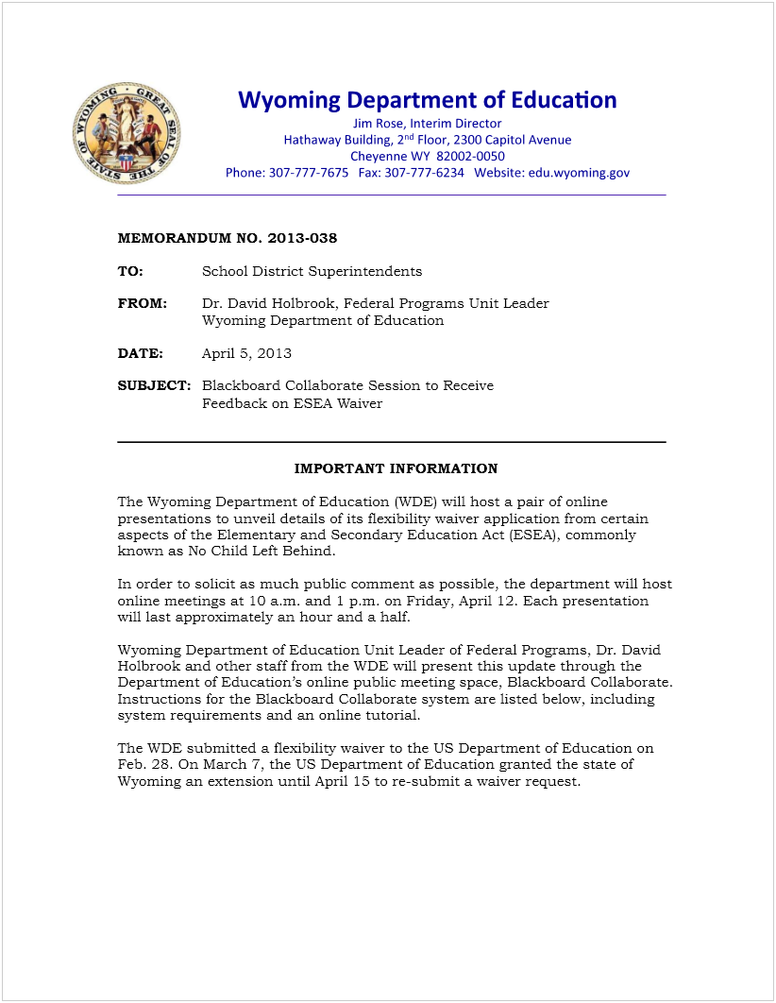
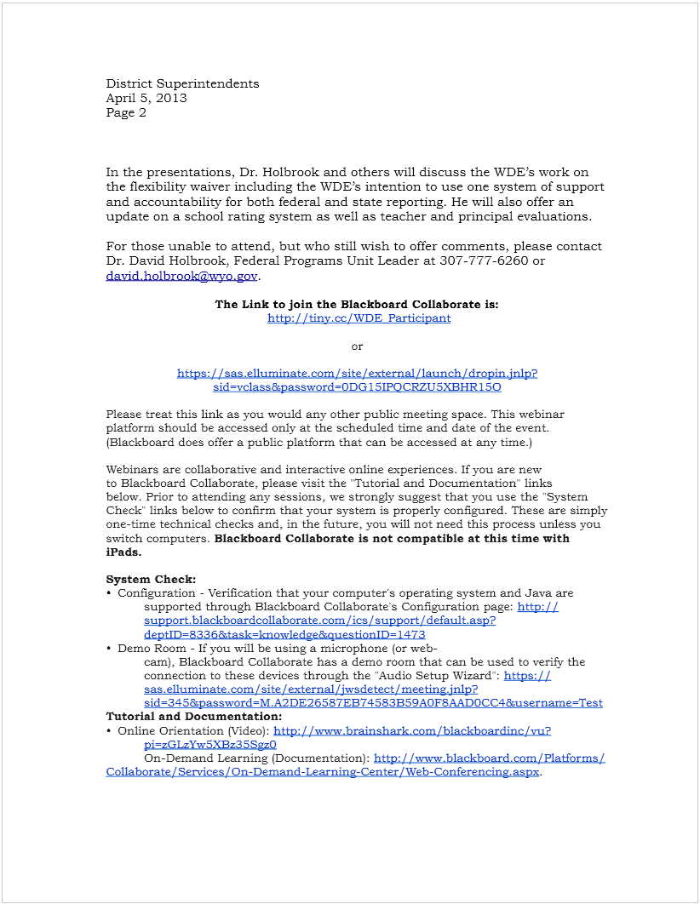
The announcement for the April 12th presentation was also published in local newspapers.

This email was received after the April 12th webinar power point was sent out to LEAs.
Metcalfe, John | April 16, 2013, 8:44 AM (9 hours ago)
to me

Thanks for providing this David. I will be using portions of it tonight briefing our school board. John

From: Tom Lacock [mailto:tom.lacock@wyo.gov]
Sent: Friday, April 12, 2013 4:17 PM
To: Thomas Lacock
Cc: David Holbrook
Subject: Powerpoint from today's ESEA waiver presentation

Hello administrators,

I thought I would pass along the power point presentation Dr. David Holbrook used in today's ESEA waiver presentation online. The presentation itself will be ready for release sometime this weekend when the recorded version arrives via web link to the WDE. At that point we will be sure to send out a link where the entire presentation to be viewed.

As always, public comments are encouraged.

Thank you for your time and have a great weekend.

--
Tom Lacock
Wyoming Department of Education
307-996-6337
tom.lacock@wyo.gov

